LEARNER GUIDE

Unit Standard Title: | USE SECURITY EQUIPMENT
Unit Standard No: | 244176
Unit Standard Credits: | 2
NQF Level: | 2



In terms of the Copyright Act 1978:

No part of this manual may be reproduced or translated in any form or by any means, electronic or mechanical including photocopying, recording or by an information storage and retrieval system without the express permission from TDA.

COPYRIGHT: TRAINING DYNAMICS AFRICA

First edition 2008 Publications disclaimer
Neither the authors nor the SETA can accept any responsibility for any legal or any other consequences, which may arise directly or indirectly as a result of the use or adaptation of or reliance upon any of the content of this material.

This material has been compiled based on the UNIT STANDARD 244176: USE SECURITY EQUIPMENT

The program has been accredited by SASSETA in the Republic of South Africa. Material compiled by:
Training Dynamics Africa

PROGRAM GUIDE7-11
- Introduction 7
- Purpose of this learning program 7
- Standards and qualifications 7
- Assessments 8
- Range statements 8
- The learning guide 8
- Learning assumed to be in place 9
- Preparation of summative assessment 11
- Roles and responsibilities 11
Study unit 1: Batons 13-25
- Introduction 15
- Types of batons 16
- The grip of the tonfa 17
- The grip and carry positions of the straight baton 18
- Defensive maneuvers with the Tonfa 18
- Defensive maneuvers with the straight baton 20
- Baton retention when a person reaches for your baton while you are in 23 a……...
- Sparring 24
- Legal guidelines 24
- Safety guidelines 24
Study unit 2: Constraint apparatus 27-36
- Definition 29
- Description of handcuffs 29
- Types of handcuffs 29
- The use of handcuffs 31
- Perform an arm bar takedown and apply handcuffs. 33
- Legal guidelines 34
- Safety guidelines 35
Study unit 3: Defensive sprays 37-45
- Introduction 39
- Definition 39
- Effects 39
- How to use Mace Self Defense Spray 40
- Safety guidelines 41
- Spray patterns 43
Study unit 4: Two way radio communication 47-59
- Introduction 49
- Definition 49
- Components of a two way radio 49
- Radio procedures 50
- Principles of voice procedure 51
- The phonetic alphabet 52
- Common words and phrases 53
- Radio controls 54
- Principles of radio procedures 57
Study unit 5: Metal detectors 61-71
- Introduction 63
- Definition 64
- Searching with a hand held metal detector. 64
- Operating a handheld metal detector 65
- Practical use of the scanner 66
- Legal guidelines when using a hand metal detector. 68
- Safety guidelines. 68
- Function and characteristics of Walk through metal detector. 69
Study unit 6: Body armor 73-82
- What is body armor 75
- Different types of body armor 75
- Standards of body armor 75
- The purpose of having body armor 78
- Benefits of wearing Body Armor 78
- Safety Instructions 80
- Legal guidelines 81
Study unit 7: Flashlights 83-93
- Introduction 85
- How to use the flashlight 87
- Changing the battery of the flashlight 88
- Carry the flash light 90
- Battery-powered vs. Re-chargeable? 91
- Safety guidelines when using a flashlight. 92
Study unit 8: Keys 95-103
- Key control measures 97
- Non-Mechanical Locks 98
- Special Security Control 99
- Locking defined 99
- Locking system components 100
- Procedures for control of locking devices 100
- Procedure for possession of locking devices 100
- Procedure for the control of keys 100
- Control of combination to combination locking devices 101
- Use of locking devices 102
Study unit 9: Maintenance of security equipment 105-117
- Safe storage of security equipment 107
- Basic maintenance check of security equipment 107
- Storage methods 116
- Procedure for reporting defective equipment 116
Glossary 119
Bibliography 121
244176 Use of security equipment 123

  - Introduction

This learning program is part of a complete qualification. For more details concerning the complete qualification please contact your service provider or alternatively the office of the SASSETA

  - Purpose of this learning program

This unit standard will enable learners to use security equipment in various situations. Learners will be able to understand when and how certain equipment may be used and under which conditions. Learners will also be able to ascertain whether the equipment is in working condition or whether it should be referred to a maintenance team. This unit standard will also enable learners to handle, store and handover security equipment.

A person credited with this unit standard will be able to:

- Explain the safekeeping and storing of security equipment.
- Demonstrate the use of security equipment.
- Confirm the working condition of security equipment.

2.1 Target group

This program is compiled for the following target group:

- Security members
- South African Defense Force members
- South African Police Force members
- Correctional Services
- Individuals who wishes to complete the NQF level 3 National Certificate in security practices.

  - Standards and qualifications

It is important that you as the learner understand and realize that this training program is not presented in isolation, but that it was developed based upon nationally recognized standards known as unit standards.

Unit standards are the “building blocks” of qualifications. All qualifications are plotted on the National Qualifications Framework (NQF).


Unit standards comprises of outcomes. An outcome is a state- ment that describes the required competency that must be demonstrated by the learner on successful completion of a training intervention.

  - Assessments

In order to assess whether a learner can actually demonstrate the desired outcomes, assessment criteria are included in the unit standard. Each outcome has its own set of assessment criteria.

The assessment criteria describe the evidence that is needed that will show that the learner has dem- onstrated the outcome correctly.

Kindly refer to the unit standard attached hereto for the assessment criteria.

It is of utmost importance that the learner fully understands the assessment criteria as listed in the unit standard, as it is the only way in which the learner will know what he will be assessed against.

The final or summative assessment is the most important aspect of this training pro- gram. It is during this process that the learner will be declared competent or not yet com- petent.

The learner will know exactly how he will be assessed, and when and where he will be assessed. All of these details must be obtained from the training provider where the learner enrolled for his program.

  - Range statements

Also included in the unit standard are the range statements in support of the assessment criteria.

The range statements indicate detailed require- ments of the assessment criteria.

  - The learning guide

The learner guide is included in this material under various learning units. The learner guide has been designed in such a manner that the learner is guided in a logical way through the learning material and requirements of the unit standard.

On completion of this skill program, the learner will be assessed against the assessment criteria as stipulated in the unit standard.

Each of the modules consists of learner outcomes to be achieved during training and development interventions, work related experience or at your own time. The learner outcomes will enable you to achieve the required level of confidence and competence in order to undergo the summative (final evaluations) assessment.

The learner needs to assess his own knowledge and skill throughout the training process by completing the learner workbook. With the completion of the workbook you start collecting evidence to proof your competence. The learner workbook will be assessed (FORMATIVE ASSESSMENT)


The learner guide will remain the property of the learner once the LEARNING PROGRAM has been completed.

    - The best results will be obtained if you start with Study Unit 1 in the Learner Guide, and work your way through it, study unit by study unit.

    - All learning outcomes are vital and must be studied (and exercised for all practical requirements) thoroughly to ensure that enough evidence for all specific outcomes is generated.

  - Learning assumed to be in place

It is assumed that a learner which registers for this program have completed a program in communication at NQF Level 3 or equivalent.

It is imperative to understand that this program are only one of the building blocks to complete Skills program 1 The complete list of unit standards for Skills program appears on the next page.

7.1 Security program matrix

Patrol Security officer/Grade E
SKILLS PROGRAM 1: SASSETA E
244177 | Conduct a security patrol in area of responsibility | Level 3 | 7 Credits
244184 | Apply legal aspects in a security environment | Level 3 | 8 Credits
244176 | Use security equipment | Level 2 | 2 Credits
244179 | Handle complaints and problems | Level 3 | 6 Credits
244181 | Perform hand over and take over responsibilities | Level 3 | 2 Credits
244182 | Give evidence in court | Level 3 | 4 Credits
12484 | Perform basic fire fighting | Level 2 | 4 Credits
116534 | Carry out basic first aid treatment in the work- place | Level 3 | 2 Credits

Access control officer/Grade D
SKILLS PROGRAM 2: SASSETA D
244189 | Conduct access and egress control | Level 4 | 7 Credits
242825 | Conduct evacuations and emergency drills | Level 4 | 4 Credits
11505 | Identify, handle and defuse security related conflict | Level 4 | 12 Credits
117705 | Demonstrate knowledge of the Firearms Control Act 2000 (Act No. 60 of 2000) | Level 3 | 3 Credits
113924 | Apply basic business ethics in a work envi- ronment | Level 2 | 2 Credits
119465 | Write/present/sign texts for a range of com- municative contexts | Level 3 | 5 Credits
114979 | Operate a computer workstation in a busi- ness environment | Level 3 | 2 Credits

Asset & reaction officer/Grade C
SKILLS PROGRAM 3: SASSETA C
113909 | Coach a team member in order to enhance individual performance in work environment | Level 3 | 5 Credits
13912 | Apply knowledge of self and team in order to develop a plan to enhance team perform- ance | Level 3 | 5 Credits
244578 | Describe how to manage reactions arising from a traumatic event | Level 3 | 2 Credits
113852 | Apply occupational health, safety and envi- ronmental principles | Level 3 | 10 Credits
13936 | Outline the legal environment of a selected industry | Level 3 | 2 Credits
119472 | Accommodate audience and context needs in oral/signed communication | Level 3 | 5 Credits
11508 | Write security reports and take statements | Level 4 | 10 Credits

  - Preparation of summative assessment

After you have worked through the LEARNER GUIDE and you are satisfied that all theoretical and practical requirements/ evidence, as stipulated by the UNIT STANDARD, can be met, you need to make your own necessary arrangements with the assessor and/ or facilitator. The training establishment will then arrange a suitable date for you to attend your pre-assessment meeting and then arrange for a suitable date to complete the final assessment.

8.1 RPL assessment

The assessment of RPL learners will be conducted in the same way as for those of new learners. The assessment pack is exactly the same and will therefore be used for new learners as well as RPL Learners. It must however be noted that learners who are applying for RPL must provide proof of previous learning and subject related experience prior to the assessment.

This proof or evidence can be in the format of certified copies (certificates) of previous learning programs that have been attended.

All the evidence will be assessed and authenticated before a learner will be allowed to enroll for an RPL program.

  - Roles and responsibilities

  - Facilitator/instructor

- Prepare to facilitate.
- Transfer of knowledge and skills

  - The role of the assessor

- Plan for the assessment
- Prepare the learner for the assessment

  - The role of the Learner

- Prepare for assessment.
- Accept the responsibility of learning.
- Accept the responsibility to produce/deliver evidence.


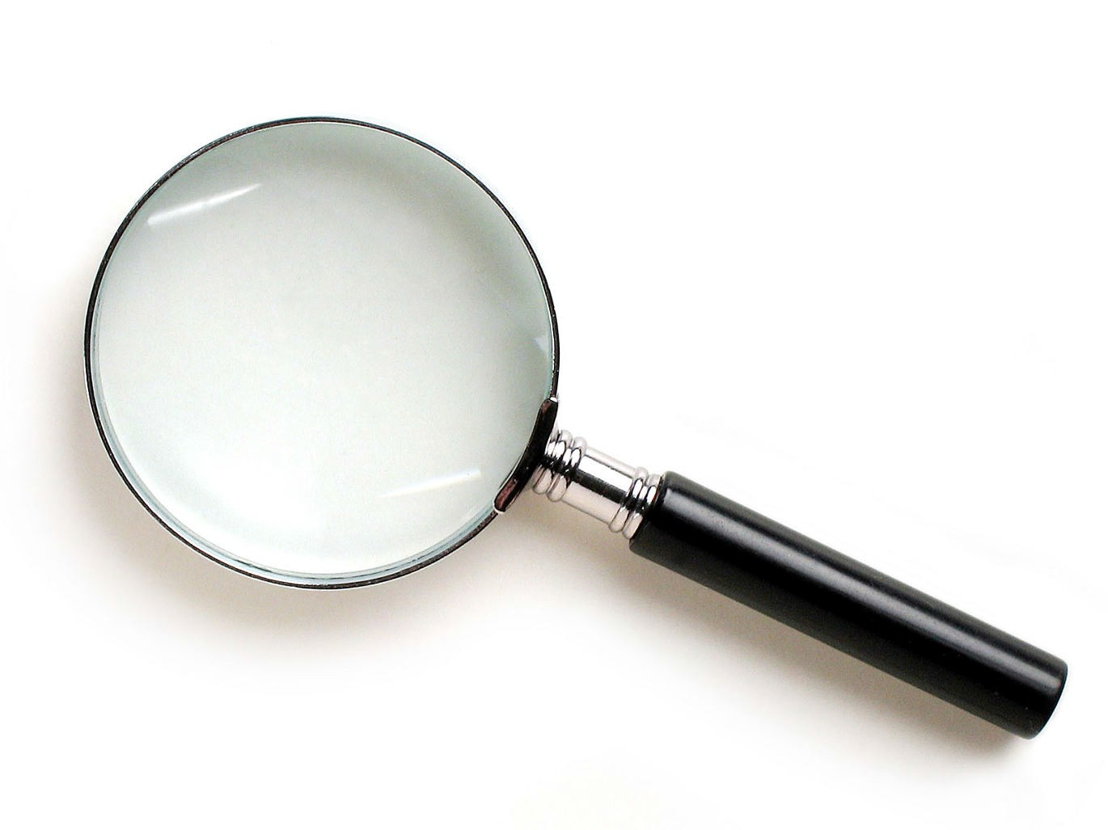
STUDY UNIT 1

BATONS

LEARNING OUTCOMES

On completion of this study unit the student will….

- Describe 2 types of batons.
- Demonstrate the common grips for 2 kinds of batons.
- Discuss safety guidelines for batons.
- Demonstrate defensive maneuver skills when using a baton/tonfa
- Demonstrate skills in baton retention.
- Explain the legal guidelines for the use of batons.
- Demonstrate the correct carry method when carrying a baton.

- Introduction

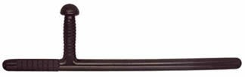
The tonfa was originally a wooden handle that fit into a hole on the side of a millstone used to grind rice and other grains, dating back to 15th century Okinawa.

The handle, which was easily disengaged from the millstone, became a very effective weapon of defense. The Tonfa's circular movements as a farm implement evolved into its rotating strikes as a weapon. They may be used for blocks, thrusts, and strikes.

In 1906, the ownership of weapons was prohibited on the Okinawan Islands by the Japanese invaders. As a result, an exploration of self-defense techniques and new weapons for self-defense began. By spinning the tonfa around the short handle, tremendous striking force may be generated. By using the long portion in conjunction with the short handle, the tonfa may be used for numerous come-a-longs and arm locks.

Two tonfa were often used simultaneously, and were very efficient against armed assailants. The side of the tonfa was used for blocking, and the ends for direct punches. Continued practice with the tonfa can help improve balance, coordination and physical strength.

The simple tonfa has a very interesting history. During the 17th Century the inhabitants of the island of Okinawa were banned by the invading Japanese government from carrying weapons such as swords and knives. Adding to this problem to the people of Okinawa was the scarcity of workable metal in the Ryukyu Islands. These conditions and the need for personal protection gave rise to the development of the Martial Arts of Okinawa: Karate and Kobudo.

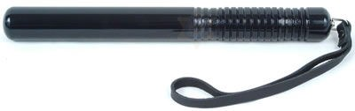
- Types of batons

  - The straight baton


A handheld device for incapacitating dangerous suspects without endangering nearby civilians. The user holds the handgrip which has a trigger connected to a source of thrust, such as an air cartridge. When the user pulls the trigger, the air cartridge is fired and extends a shaft outwards, which has
an end piece at the other end for catching suspects. The end piece unfolds into a flat surface and has needles with retractable barbs attached to the flat surface. These retractable barbs engage the suspect and incapacitate him. A cam inside of the end piece can be operated to retract the barbs and release the suspect.

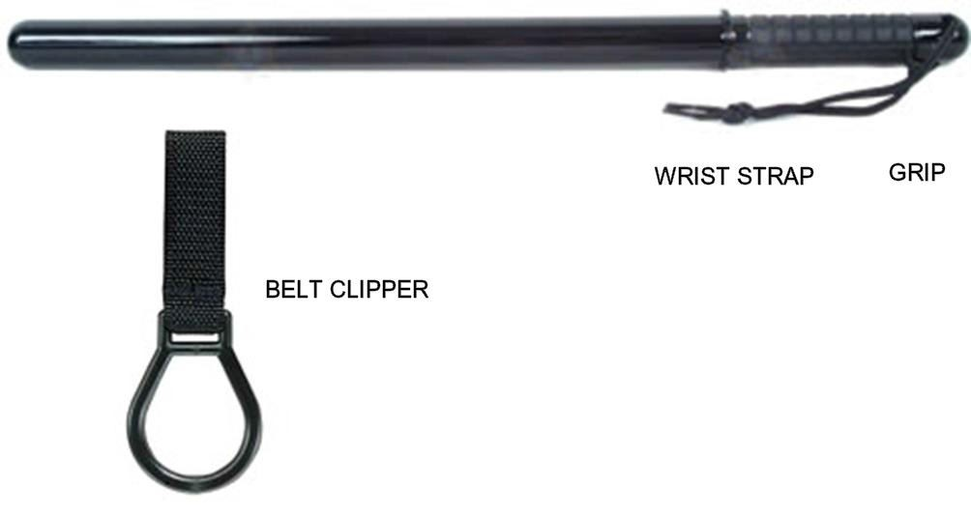

  - The tonfa

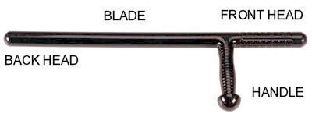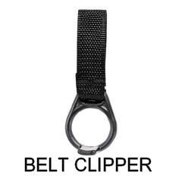
Tonfa are a martial arts weapon for self defense and martial
arts training for attack prevention.
- The grip of the tonfa



This is the most basic of grips and will enable you to protect yourself quite well.

Tonfa are gripped for the purposes outlined here in a very easy to learn manner by simply gripping the handle with your fist and holding the long end of the shaft parallel to your forearm.

- The grip and carry positions of the straight baton

Vertical carry position. Using the one-hand grip, hold your baton down and slightly out to the side of your strong leg, vertical to the ground. Raise your support hand chest high and place it in a good defensive position.

Outside-the-arm carry position. Using the one-hand grip, hold your baton on the outside of your strong upper arm, just below your strong shoulder, horizontal to the ground. Raise your support hand chest high and place it in a good defensive position.

Two-handed carry position. Using the one-hand grip, place your support hand on the long portion of your baton, about one hand width from the long end. Completely grip the long portion with your fingers, centering the baton on your midline at a 45-degree angle.

- Defensive maneuvers with the Tonfa

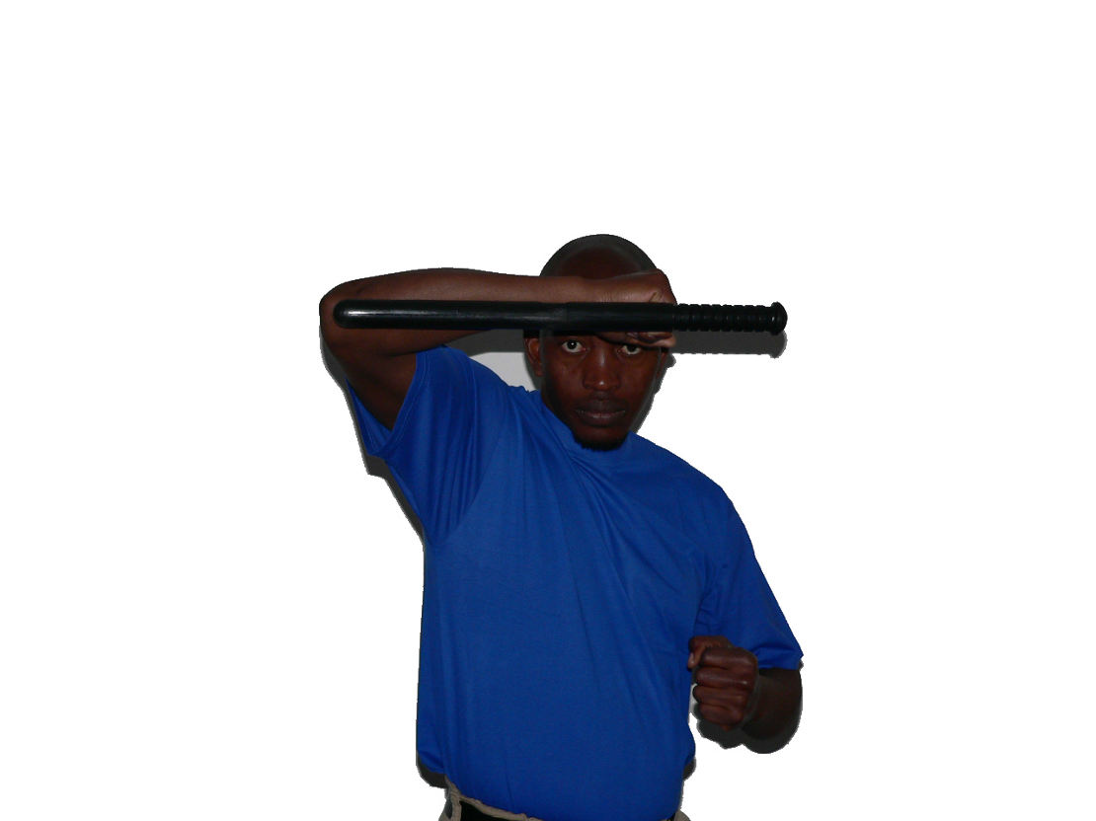
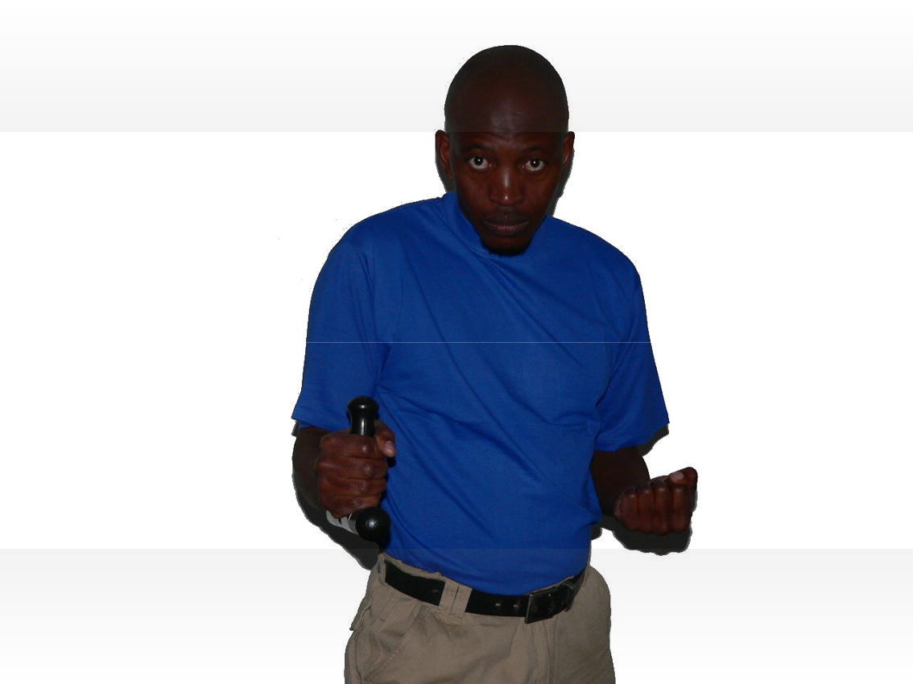
Lower Section Block: Swiftly sweep your arm swiftly down across and past your body line. This will help ward off any low attacks and guard the legs.
Low attacks are what many people have trouble with spotting and defend- ing against. I particularly enjoy striking the knee during controlled sparring.

Raising Block: Raise the baton well above your head on a 45 degree angle. The angle is important to deflect the attack down and away from your body. If the angle it too flat then you will take the force of the strike heavily and if the angle if too sharp then you lessen the chance of your block being successful. This block works well against a vertical strike and remember to block well above the head.

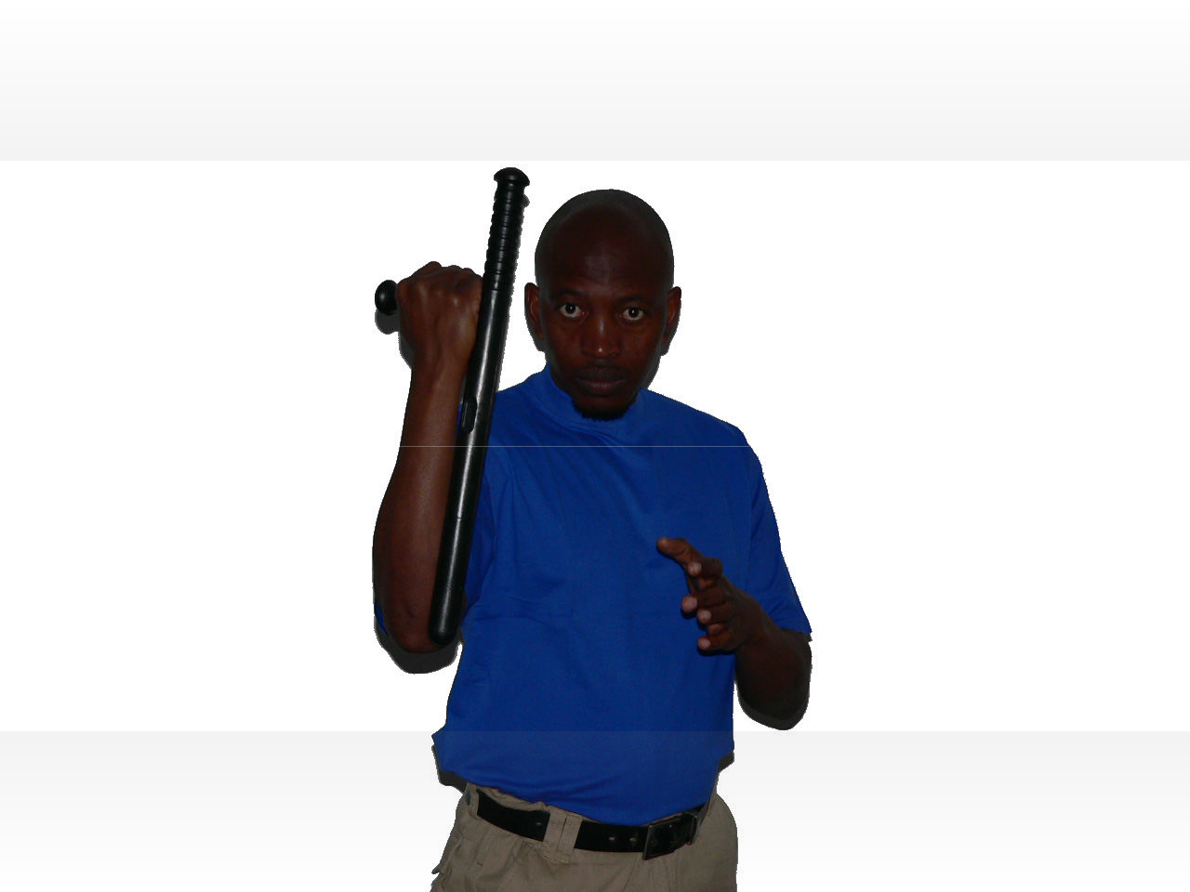
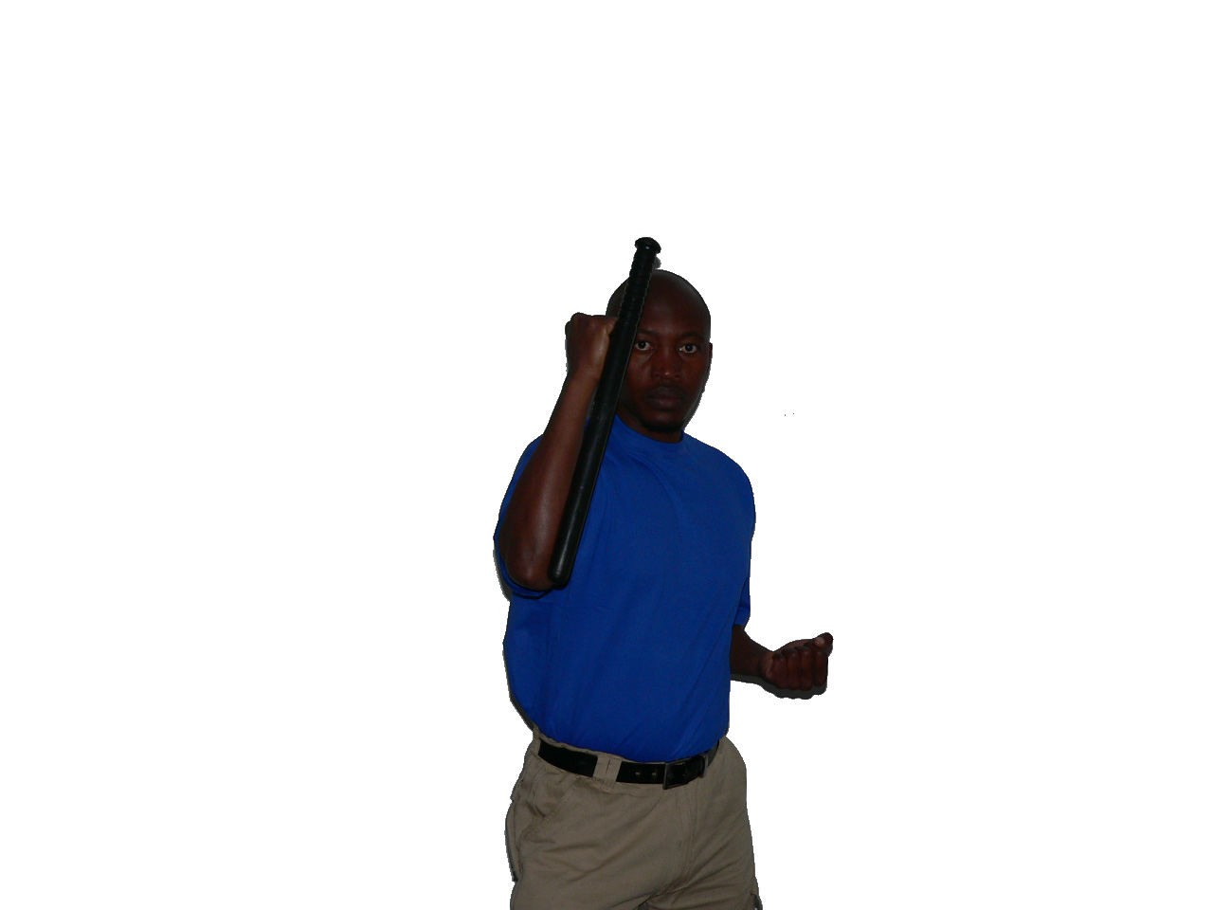
Inner Forearm Block: Swing your
arm across the front of your body using an outside in motion. This blocks the opponent’s strike into your body and will hopefully expose their blindside to your subsequent attack. Make sure you turn the hips in as you block to ensure your body is well out of the way of the attack. This is an excellent block to use against vertical strikes.
Outer Forearm Block: Swing your
arm out and across your body using and inside out motion. This is a fast blocking technique and will leave both combatants open for the next attack. Make sure your other arm is on guard and ready for another attack. This also is an excellent block against
vertical strikes.
Cross Block: A more advanced blocking technique. The Cross Block can be employed either against an upper vertical attack or a lower upward swinging attack. You must swing both batons out in front of you and form a cross shape to block and temporarily trap the incoming strike.

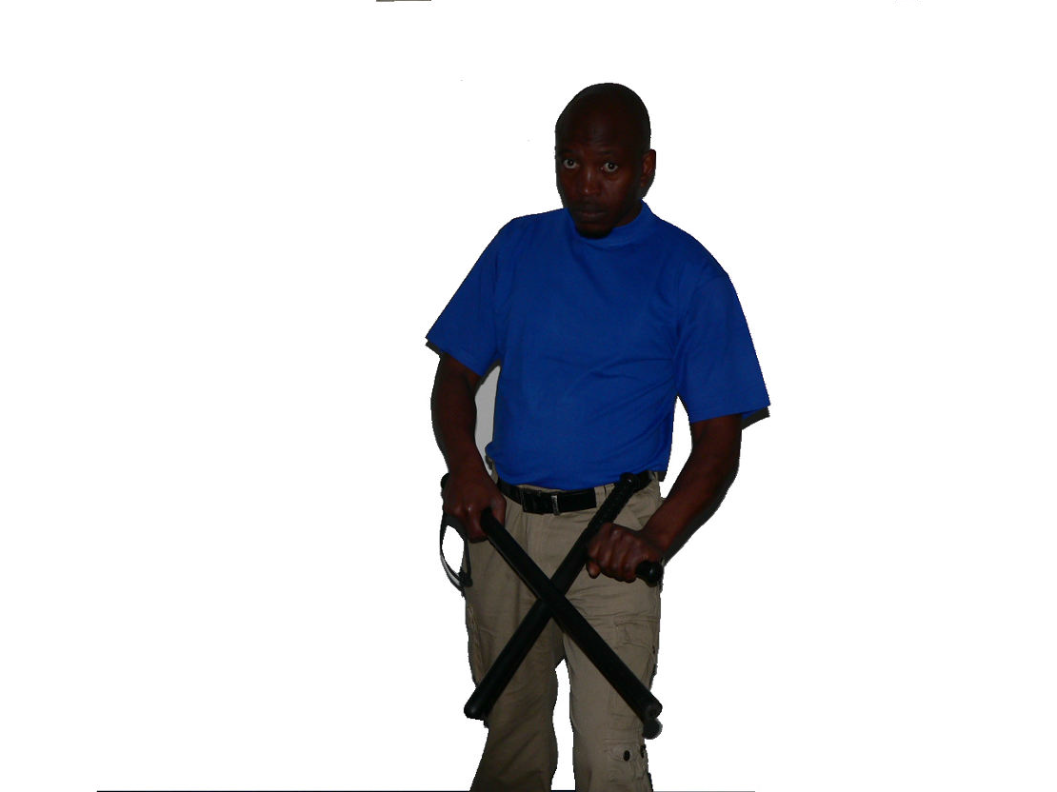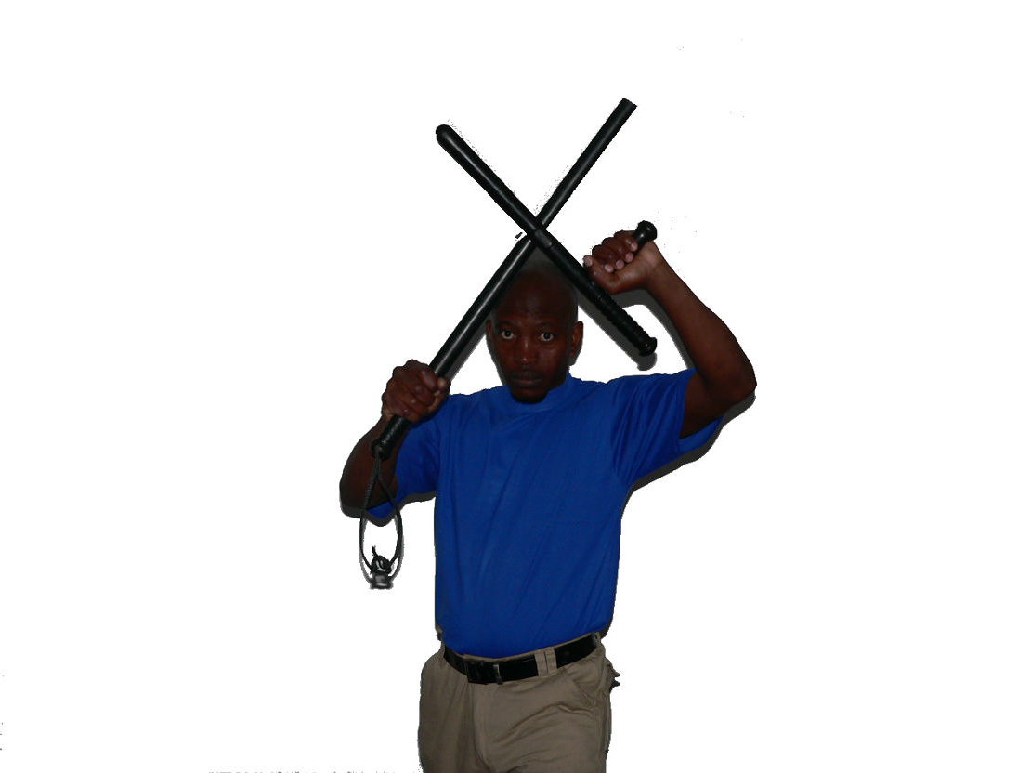

Some Major Considerations:

  - Practice, practice, practice.
  - Start slow and simple, then build the speed and complexity up over time.
  - Don’t be over excited and get carried away with force
  - Remember you are learning defense. Unless you and your partner are incredibly advanced in the use of the tonfa and have a mutual agreement do not strike back!
  - Never try to hurt your opponent.
  - Never train whilst intoxicated, drugged or in a bad mood.
  - If you are injured in any way, stop immediately and assess the damage.
  - If your opponent accidentally hits you do not take it personally and never try to get revenge!
  - Keep your tonfa well maintained.

- Defensive maneuvers with the straight baton

6.1 Blocks:

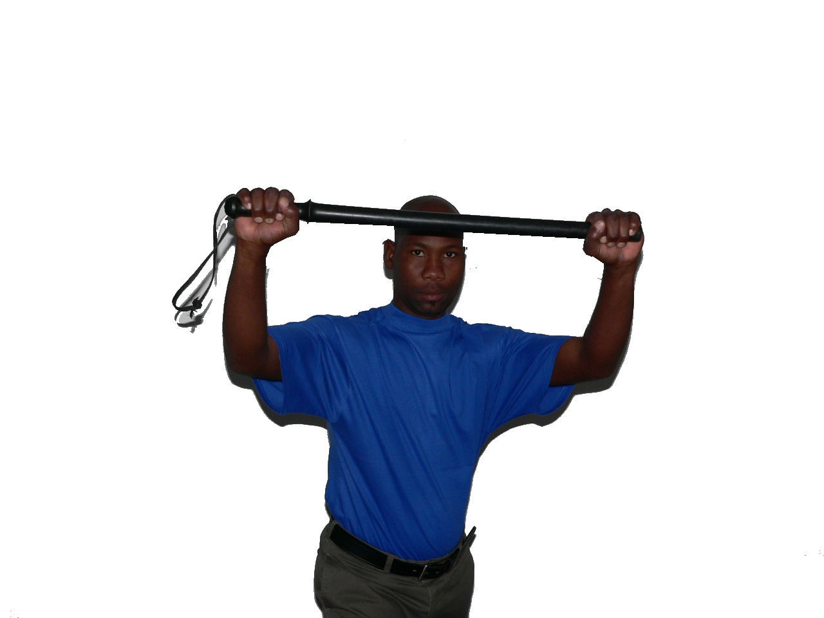
High block. Using the two- handed carry position, raise your baton up in front of your body until the long portion is above and in front of your forehead. Position your support hand, with fingers open, behind the long portion of the baton as you block the object.

Middle block. Using the two-handed carry position, move your baton to the middle of your body at a 45-degree angle. Keep the long portion pointing up and slightly forward of the grip portion that is pointing down. Position your support hand, with fingers open, be- hind the long portion of the baton as you block the object.

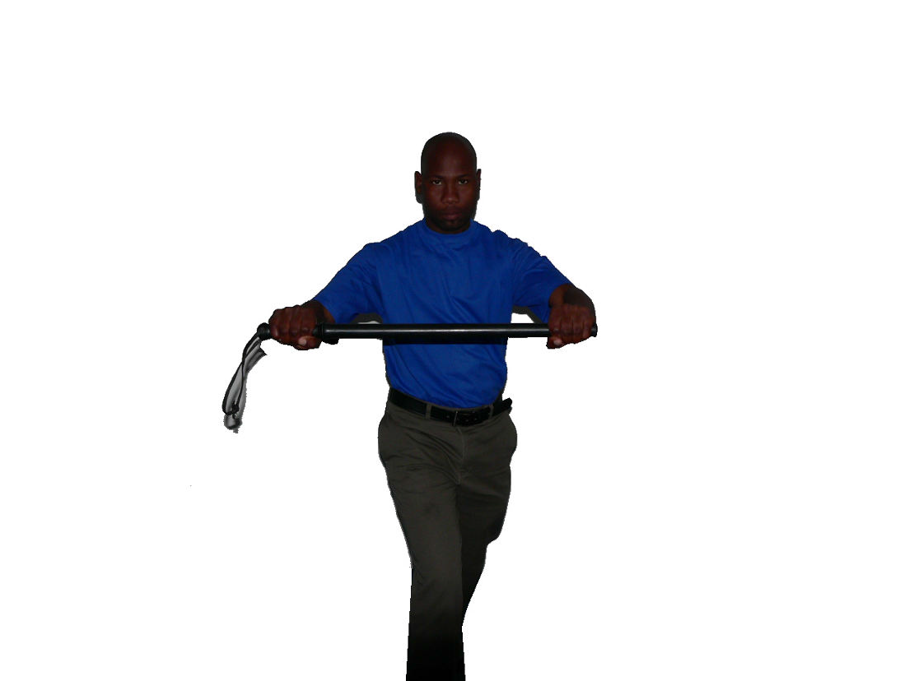
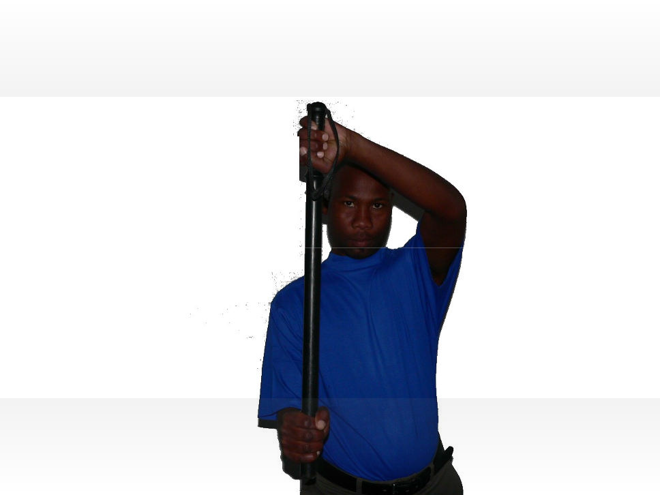
Low block. Using the two-handed
carry position, move your baton hori- zontally down in front of your body to just below your groin. Position your support hand, with fingers open, behind the long portion of the baton as you block the object.
Strong-side block. Using the two-handed
carry position, move your baton vertically toward your strong side, keep the grip portion pointing straight down and the long portion pointing straight up. Position your support
6.2Strikes and jabs

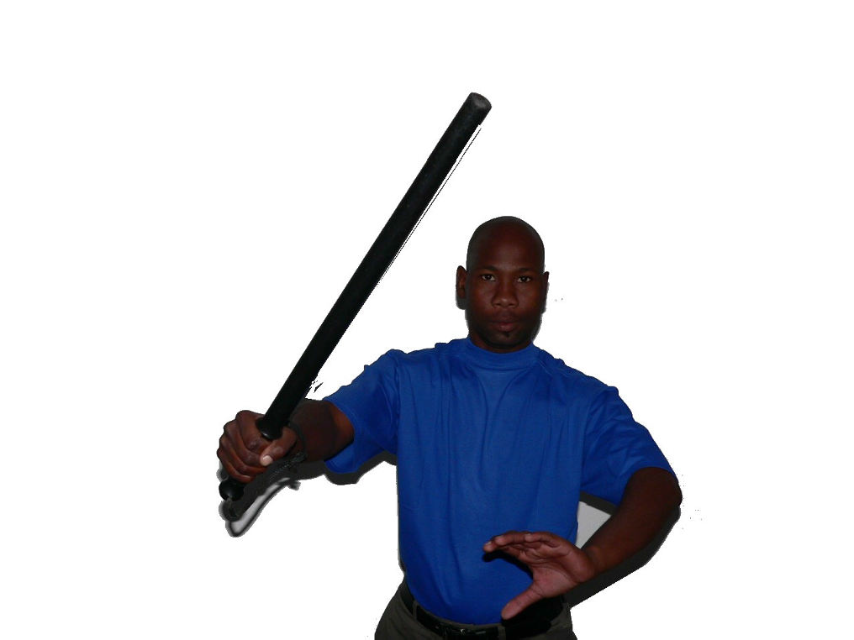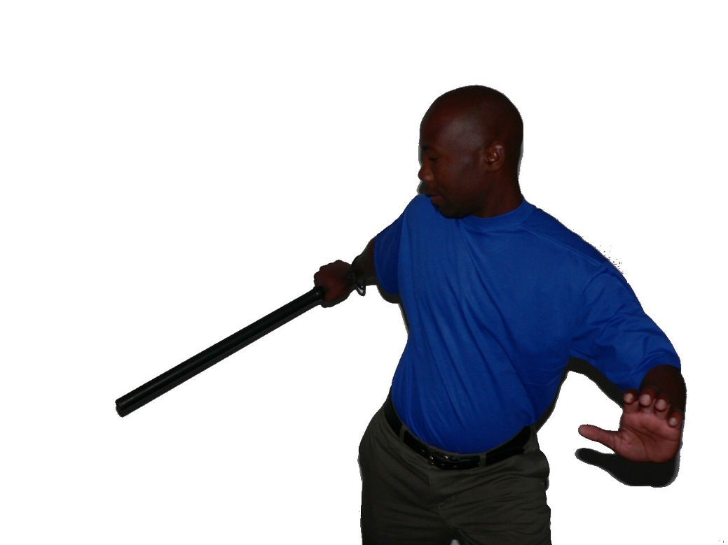
Forward strike. Using a one-hand carry
position, quickly move your baton across your body from your strong side to your support side. Keep your palm facing up as you deliver the counter-strike technique horizontally or downward diagonally.
Reverse strike. Using a one-hand carry
position, quickly move your baton across your body from your support side to your strong side. Keep your palm facing down as you deliver the counter-strike technique horizontally or downward diagonally.

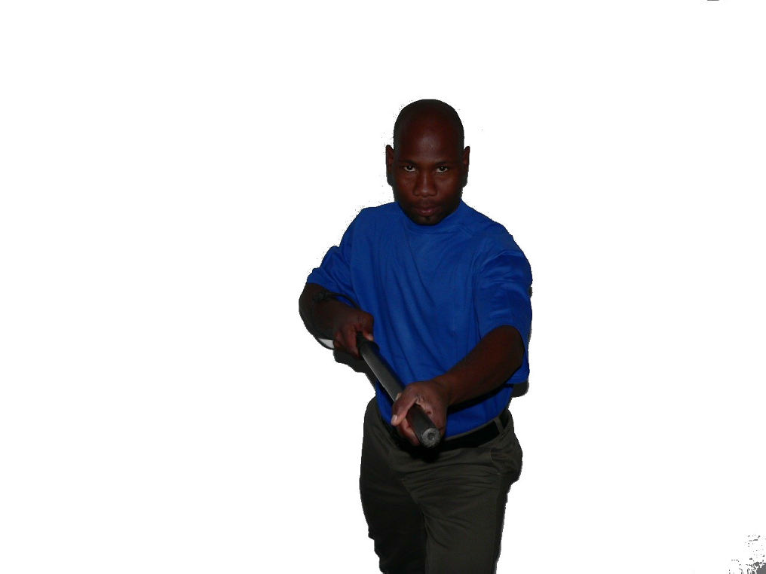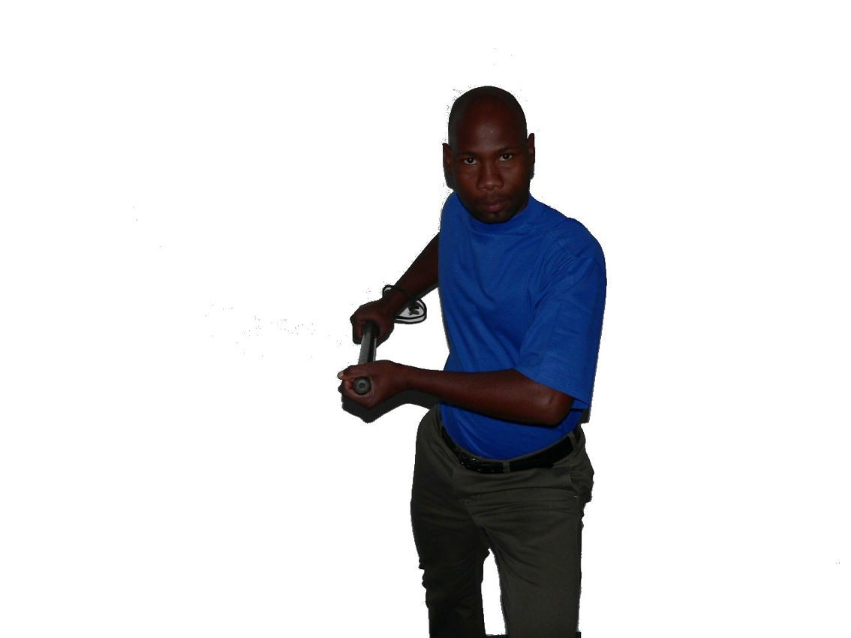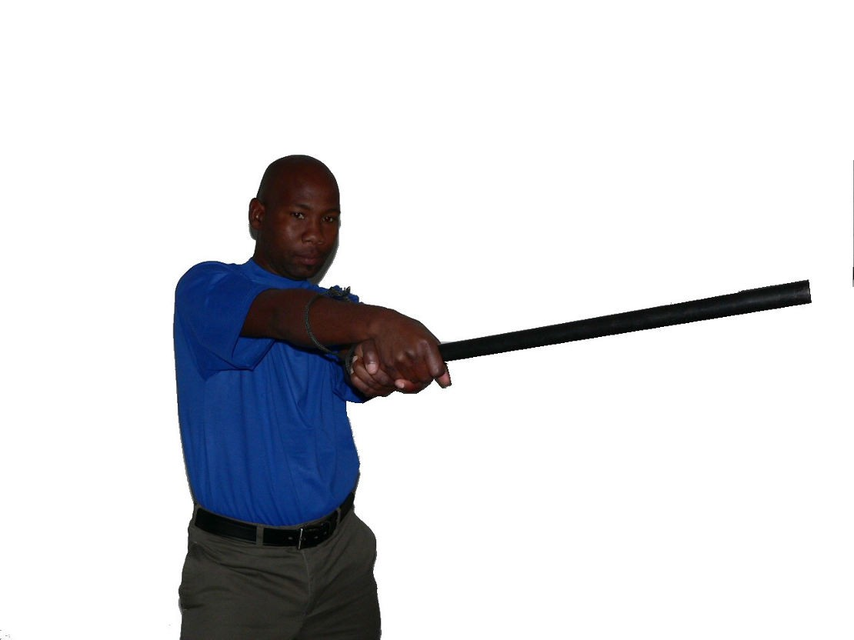
Front jab. Use the two-handed carry posi-
tion to thrust the long end of your baton for- ward using both your strong and support hands. Thrust the baton forward horizon- tally and slightly downward.
Rear jab. Use the two-handed carry
position to quickly thrust the grip end of your baton to the rear using both your strong hand and your support hand. Thrust the baton rearward hori- zontally and slightly downward.
Strong-side horizontal strike. Use
the two-handed carry position to rotate your baton horizontally. Pull back with your support hand as your strong hand drives the grip portion or the grip end forward toward your target. Thrust the grip end or grip portion horizontally, while using both your hands and your strong-side hip to generate power.

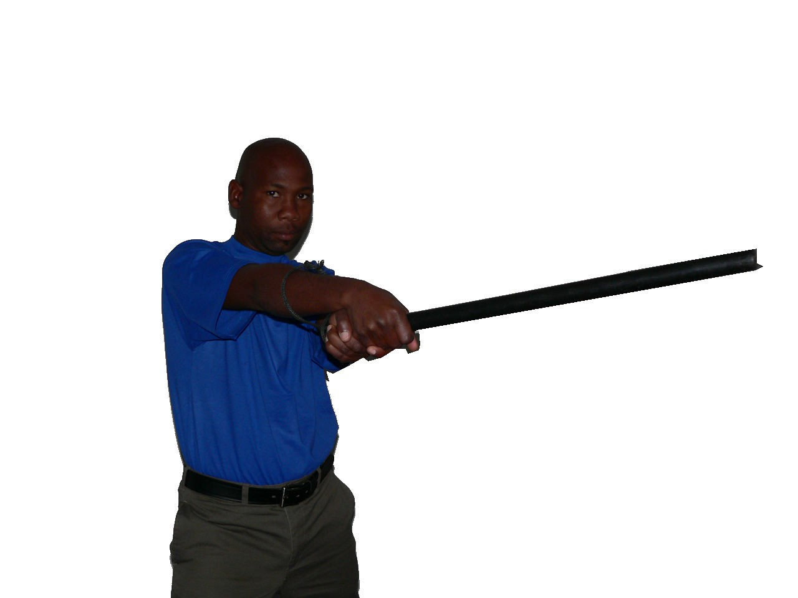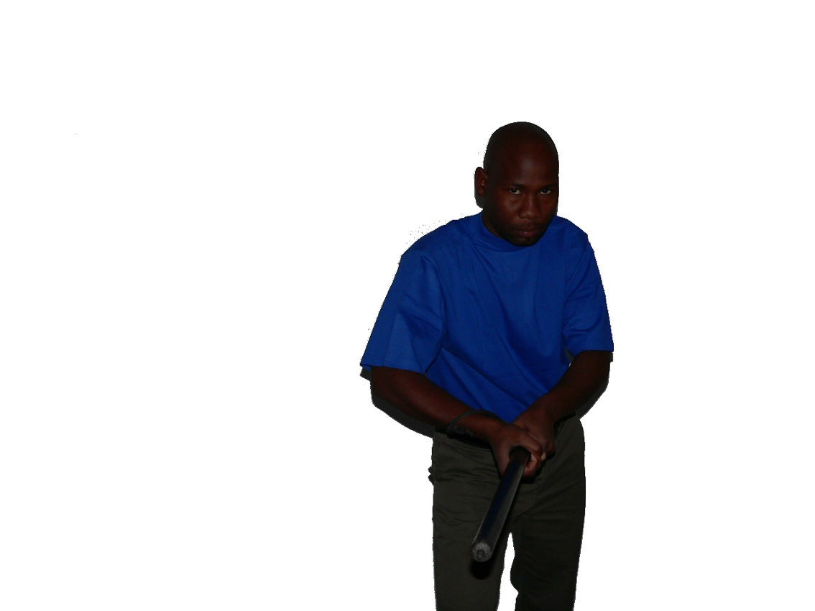
Support-side horizontal
strike. Use the two-handed carry position to rotate your baton hori- zontally. Pull back with your strong hand as your support hand drives the long portion or long end for- ward toward your target. Thrust the long end or long portion hori- zontally while using both your hands and your support-side hip to generate power.
Middle strike.Use the two-handed
carry position to sharply thrust the long portion of your baton forward horizontally.Extend both of your arms at the conclusion of the forward thrust. Use your entire body to generate power.

- Baton retention when a person reaches for your baton while you are in a……...

One-hand carry position. As the suspect grips the long portion of your baton, quickly grab the long end with your support hand. Rotate your baton in a circular motion using both of your hands to the outside of the suspect's gripping hand(s), forearm(s), or wrist (s). Simultaneously take a step to the outside of the suspect's body. If one of the suspect's hands is on the long end when you try to place your support hand there, grab the hand on the long end and continue as if it were the long end. Once the long portion is above the suspect's hand(s), forearm(s), or wrist(s), drive the baton in a strong downward motion to completely separate the hold on your baton using your strength and body weight.

Two-handed carry position. As the suspect grips the long portion of your baton, quickly rotate your baton in a circular motion, placing both of your hands to the outside of the suspect's gripping hand(s), forearm(s), or wrist(s). Simultaneously take a step to the outside of the suspect's body. Once the long portion is above the suspect's hand(s), forearm(s), or wrist(s), use your strength and your body weight to drive the baton in a strong downward motion to completely separate the hold.

- Sparring

Sparring with the tonfa can be done against a multitude of different weapons. These can include swords, staffs, spears, knives and really any weapon you can think of. I would not recommend practicing against steel or edged weapons though. Sparring against these will lessen the life of your tonfa and also increase the likelihood of any accidental injury being much worse than it could have been. Experienced Martial Artists should be able to easily adapt their own style’s blocks and forms to match the ability of the Tonfa. You will be amazed at how your Martial training will benefit from this form of sparring.

- Legal guidelines

Batons, although not as lethal as firearms, can be legally regarded as deadly weapons so you should exercise care when using one. In the learner reference guide on legal aspects, the use of force in effecting an arrest is discussed. So, do not use the baton unless it is absolutely necessary, for instance, in order to protect a life or to prevent a person from fleeing during arrest. For the latter remember to use minimum, reasonable force.
- Safety guidelines

There are not many personal safety risks involved in using a baton. The major factor is to be careful not to hit yourself as this can prove to be painful. Other aspects to bear in mind are:

- Do not swing your baton around. Chances are that you might hit an innocent bystander.

- Make sure to carry your baton in such a manner that it cannot be taken from you and used against you.

- Exercise care when entering and existing vehicles as the baton might damage other equipment inside the vehicle.

- Do not hit hard surfaces with the baton as this might cause the baton to break and the pieces might hurt yourself or bystanders. The impact created when hitting a hard surface might cause injury to your arm, hand and wrist.


STUDY UNIT 2
CONSTRAINT APPARATUS
LEARNING OUTCOMES

On completion of this study unit the student will….
- Describe 2 types of handcuffs.
- Describe the purpose of handcuffs.
- Demonstrate skills and knowledge for the correct use of handcuffs
- Discuss the legal guidelines that apply when using handcuffs.
- Describe the safety aspects for the use of handcuffs.

- Definition

Handcuffs are restraint devices designed to secure an individual's wrists close together.

- Description of handcuffs

They comprise two halves, linked together by a chain or hinge. Each half has a rotating part which engages with a ratchet which is closed around a person's wrist. Without the key, the person cannot move their wrists more than a few centimeters (inches) apart, making many tasks difficult or impossible. This is usually done to prevent suspected criminals from escaping police custody.

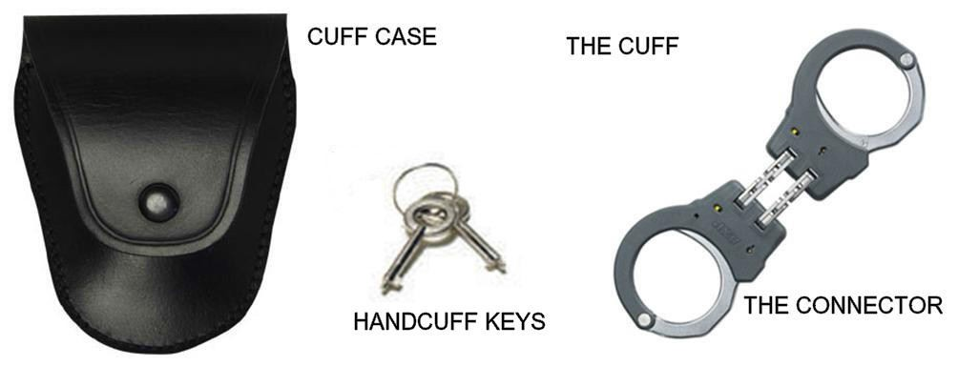
- Types of handcuffs

There are two distinct subtypes of contemporary metal handcuffs:

- one in which the cuffs are held together by a short chain,
- and another, of more recent origin, which uses a hinge for this purpose.

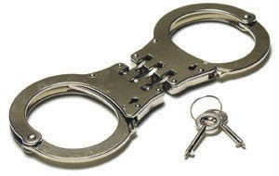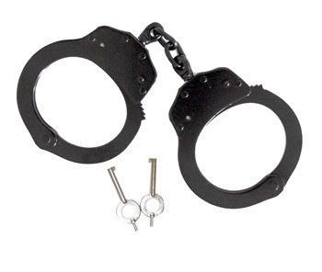

Since the hinged handcuffs are somewhat smaller when fully extended they are seen as being more easily utilized by a police officer who has relatively small hands, and are also regarded by some observers as more secure because the wrists end up being held closer together than with the chain subtype, and are also bound more rigidly. A third type, the rigid handcuff, has a metal block or bar between the cuffs. Whilst bulkier to carry it permits several variations in cuffing and, with one hand cuffed, can be used in control and restraint techniques. Various accessories are available to improve the security or increase the rigidity of handcuffs, including boxes that fit over the chain or hinge and can themselves be locked with a padlock.
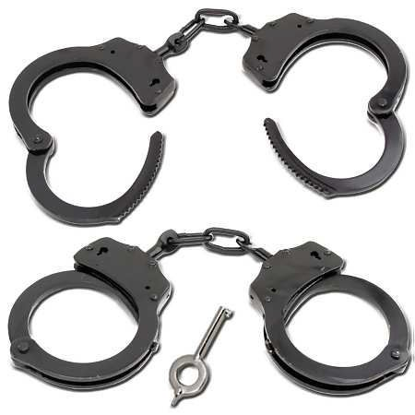
  - Double locks

Handcuffs with double locks have a lock-spring which when engaged, usually using the top of the key, stops the cuff from ratcheting tighter to prevent the suspect from tightening them. Tightening could be intentional or by struggling, when tightened the handcuffs may cause nerve damage or loss of circulation. Double locks also make picking the locks more difficult.

  - Plasticuffs

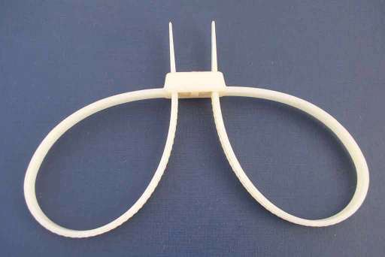
Plastic restraints, known as wrist ties, plasticuffs, flexicuffs, flex-cuffs, tri-fold cuffs, or zip-strips, are lightweight, disposable plastic strips resembling electrical cable ties. They can be carried in large quantities by security officers and are therefore well-suited for situations where many may be needed, such as during large-scale protests and riots.


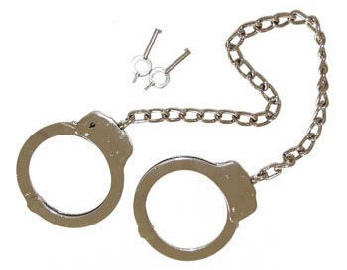
3.3Leg irons

On occasions when a suspect exhibits extremely aggressive behavior, leg irons may be used as well; sometimes the chain connecting the leg irons to one another is looped around the chain of the handcuffs, and then the leg irons are applied, resulting in the person being "hog-tied".
UNIT STANDARD 244176: USE SECURITY EQUIPMENT

Keys

Most modern handcuffs can be opened with the same standard universal handcuff key. This allows for easier trans- port of prisoners and keeps one out of trouble if one loses one's keys.
However, there are handcuff makers who use keys based on different standards. Maximum security handcuffs require special keys. Handcuff keys usually do not work with thumbcuffs.

- The use of handcuffs

  - Compliant suspect

- Tell the suspect to turn and face away from you, spread his feet apart until you tell him to stop, and point his toes out. The suspect's feet should be more than shoulder width apart.

- Tell the suspect to lock his elbows and move both arms back along his side until both arms are fully extended behind him, keeping his elbows locked.

- Tell the suspect to turn both hands until his palms are turned outward, with his thumbs pointing up, and bend forward at the waist until told to stop. The suspect should be bent at the waist at least a 45-degree angle.

- Tell the suspect not to move. Check your position, and adjust as necessary.

- Shuffle up to the suspect, staying out of arms reach, and tap one of the suspect's hands. At the same time, move back and be ready to respond to resistance by the suspect. This is an "attitude" check to determine if the suspect is planning to resist handcuffing.

- Take out your handcuffs using your strong hand, and position them in a proper carry position. Do not divert your eyes from the suspect.

- Do not make any handcuff noise, such as ratcheting the single strand.

- Approach the suspect carefully, from the outside, at a 45-degree angle.

- Use your support hand to grasp the back side of the suspect's hand (using a reverse-handshake grip) at the knuckles where fingers meet. Place your support hand(thumb) over or under the suspect's thumb, depending on the size of your hand.

- Pull the suspect's hand back away from his body. Position the center of the single strand of the bottom handcuff on the suspect's handcuffing notch at the base of his thumb, and push the handcuff on using one smooth motion. As the single strand rotates and catches the latch, snug up the cuff using either the index finger of your support hand or the little finger of your strong hand.

- Ensure that the cuff is snug, then instantly release your reverse handshake grip and move your support hand to grip the suspect's second hand in a handshake grip at the knuckles where the fingers meet the hand. Place your support hand (thumb) over or under the suspect's thumb, depending on the size of your hand.

- Grip the suspect's second hand, then instantly position the top cuff over the suspect's handcuffing notch at the base of the thumb and push the cuff on with one smooth motion. Snug up the cuff using either the index finger of your strong hand or the index finger of your support hand.

CAUTION: DO NOT RELEASE YOUR HANDSHAKE GRIP. ENSURE THAT YOU MAINTAIN POSITIVE PHYSICAL CONTROL OF THE SUSPECT.

- Release your grip on the handcuffs while maintaining a firm handshake grip on the suspect's hand with your support hand. Check the cuffs for correct fit around the suspect's wrists. Adjust the handcuffs as necessary, without releasing the grip you have with your support hand. Engage the double-lock mechanism in both handcuffs without releasing your handshake grip on the suspect.

  - Non-Compliant suspect Performance Steps:
Place the suspect in a rear-wristlock position and apply handcuffs.

- Escort the suspect to the nearest fixed object or structure.
- Give loud commands, as appropriate.
- Position the suspect flat against a supporting fixed object or structure so that the controlled shoulder joint cannot move forward.
- Use your support side and apply body weight against the suspect to further enhance the stability of the position.
- Tell the suspect to extend his uncontrolled arm straight out at a 90 degree angle, palm facing out.
- Reverse the angle of the wristlock by going palm to palm with the suspect's hand and your strong hand. Release your support hand and re-grip the suspect's hand with your support hand. Bend the wrist back so that the fingertips are pointing toward the suspect's back. Create enough space between your support wrist and the suspect's wrist to allow for handcuffing.

- Take out your handcuffs with your strong hand, without rotating your trunk/hip or changing the position of the wristlock. Assume the proper carry position for hand- cuffs.

- Position the single strand of the bottom handcuff above the thumb side of the suspect's wrist. Push the handcuff on and snug it up.

- Move control of the wristlock to the handcuffs by moving your support hand down to your strong hand, and exchanging hand positions. Your support hand should now be holding the handcuff in a proper carry position, with the single strand down.

- Tell the suspect to bring his other hand to the small of his back, then grasp the second hand with your strong hand in a handshake grip at the knuckles where the fingers meet the hand. Your strong hand may be placed over or under the suspect's thumb, depending on the size of your hand.

- Position the second cuff over the thumb side of the second wrist. Push it on with a smooth motion and snug it up.

- Maintain your support-hand grip on the handcuffs, and release your strong-hand grip. Use your strong hand to retrieve your handcuff key, double lock the handcuffs, and return the key. Use your strong hand and reapply the wristlock. Release your support-hand grip and slide your support hand to the suspect's controlled elbow and grip it. This places the suspect in the handcuff escort position.

- Perform an arm bar takedown and apply handcuffs.

- Move your feet and your body to above the suspect's controlled shoulder, without moving the suspect's arm or your hands. Do not straddle the suspect's head.

- Move your support foot forward until your toe touches the top of the suspect's shoulder. Place the shin area of your support leg across the suspect's controlled shoulder blade; do not use your knee.

- Place your strong knee on the ground next to and outside of the suspect's controlled arm. Squeeze the suspect's controlled arm between your legs.

- Place your support hand on top of the wristlock, and release your strong hand.

- Retrieve your handcuffs with your strong hand and place them in a proper carry position.

- Rotate your strong hand, palm up. Place your strong hand between yourself and the suspect's controlled wrist while keeping your strong hand palm up.

- Align the bottom handcuff (the one closest to your little finger) with the suspect's wrist. Straighten the suspect's wrist with your support hand. Push the bottom handcuff straight onto the wrist with your strong hand and snug it up.

- Place the suspect back in the wristlock using your support hand.

- Tell the suspect to bring the other hand to the small of his back. As the hand reaches the small of his back, transfer control of the controlled arm to the handcuffs and your strong hand, release your support-hand grip, and reach down and grip the suspect's thumb and index finger.

- Lift the suspect's un-handcuffed hand straight up a few inches. Move your strong hand down toward the un-handcuffed hand and cuff up on the little-finger side of the suspect's wrist.
- Maintain your body position and release the handcuffs. Retrieve your handcuff key, double lock the handcuffs, and return the key.

- Legal guidelines

Using handcuffs can have very serious consequences, especially if used incorrectly. Handcuffs should only be used if:

- The arrest is lawful;

- It is absolutely necessary to use them in order to prevent an arrested person from fleeing;

- They are applied in such a manner that the arrested person is not injured by their application;

- The dignity of the arrested person is kept in mind (for example, do not handcuff a person publicly if he submits to the arrest).
Please note:

Never handcuff a person to another object like a fence, table or security gate. This could result in a civil law suite, especially if done in public. (Have you noticed how the public stares at an arrested person?).

Never leave the handcuffed suspect alone. This creates an opportunity for escape. Remember that while he is in your custody, you are responsible for his well being. A third party may assault the suspect in your absence and you will be held responsible.

- Safety guidelines

- Handcuffs (especially the type used by security officers) have one shortfall: the keys are interchangeable. This means that if the arrested person has handcuffs keys, he can easily free himself and escape.

- A suspect’s hands should always be cuffed behind his back making use of the double lock function of the cuffs. The double lock function requires more than one action with the key before the ratchet will be released.

- Never handcuff a suspect to your person. As you have seen in the movies it is possible for him to overpower you, injure you and escape.

- If you carry a firearm, make sure that it is out of reach of the suspect at all times, especially while placing or removing the cuffs.

- They are called handcuffs for a reason - do not use them as leg or ankle cuffs, and don’t ever handcuff a hand to an ankle!

- Never handcuff two or more suspects to each other. This creates a security risk as well as a risk of injury to the suspects.


STUDY UNIT 3
DEFENSIVE SPRAYS
LEARNING OUTCOMES

On completion of this study unit the student will….
- Discuss the purpose of defense sprays.
- Explain the effects of defensive sprays.
- Demonstrate skills and knowledge in the correct use of defensive sprays.
- Explain the various spray patterns of defensive sprays.
- Describe the safety aspects for the use of defense sprays.

- Introduction

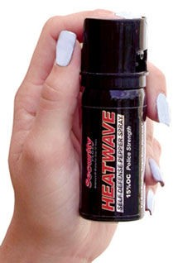
The most popular, non-lethal, personal defense product on the market today is the self defense spray (also known as pepper spray). The primary chemical compound used in self defense spray today is OC (Oleoresin Capsicum) which is a natural chemical derived from hot pepper plants. OC pepper is an inflammatory agent which causes two reactions when an individual is sprayed with this type of pepper spray. First, the person's eyes clamp shut, hard. If the person manages to open their eyes, they are unable to see well because the OC pepper dilates the capillaries of the eyes and causes temporary blind-
ness. Second, an immediate fit of uncontrollable coughing doubles the person over and often sends them to their knees. The OC pepper causes an instant inflammation of breathing tissues making breathing difficult. The condition is temporary but very debilitating. OC pepper has the affect of putting up a "brick wall" between the assailant and victim even if they are on drugs, drunk or psychotic.

- Definition

Pepper spray (also known as OC spray (from "Oleoresin Capsicum"), OC gas, capsicum spray, or oleoresin capsi- cum) is a lachrymatory agent (a chemical compound that irritates the eyes to cause tears, pain, and even temporary blindness) that is used in riot control, crowd control, and personal self-defense, including defense against dogs and bears.

- Effects

To achieve the desired effects, a defense spray must be aimed towards the face of the aggressor. The general effects of most defense sprays are

- Disorientation
- eyes slamming shut
- restricted breathing
- uncontrollable coughing
- Blindness
- and intense burning sensation.

Effects generally last 20 to 30 minutes.

- How to use Mace Self Defense Spray

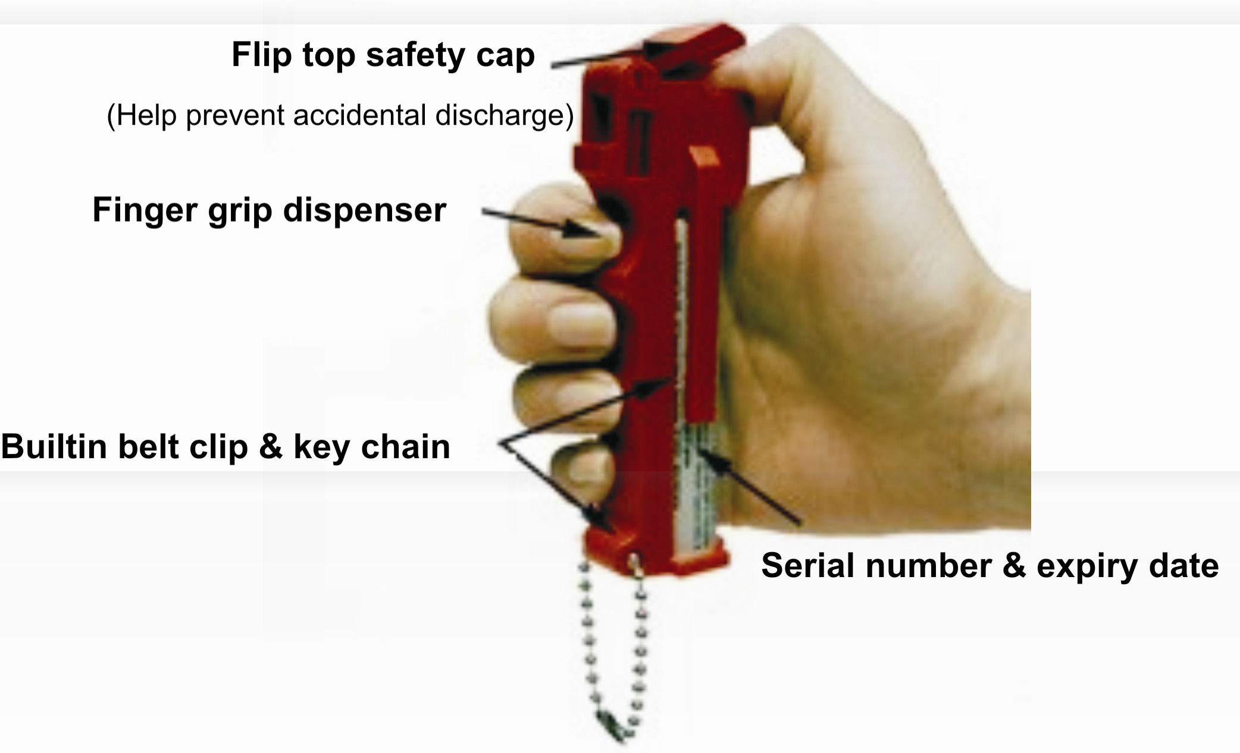
Mace Triple Action self defense spray contains a unique formulation of CN-tear gas and OC-pepper solution in a solvent blend with dry nitrogen as a propellant. Together they provide our strongest, most effective and humane deterrent available for protection against attack.

When you sense that you are in a potentially dangerous situation, carry your Mace defense spray in your hand, slip your thumb under the safety cover and be ready to spray the assailant by pressing down on the red button with your thumb.

Notice how the unit is shaped so that you can tell by the feel how it should be held. The safety cover will prevent access to the red button if you hold the unit backward. The shape of your self defense spray will enable you to know, even in the dark or in a stressful situation, when the device is properly oriented and ready for use.

If you have to use your defensive spray, point and spray short bursts at the facial area of your assailant. Because of the oleoresin capsicum, direct eye or nasal contact offers more favorable effects.

Do not attempt to punish the attacker by continuous spraying because you may cause unnecessary suffering. Do not try to take the attacker into custody-you might be injured if you do. Contact the police when you are safely away.

Your self defense spray is designed to be actuated in short 1/2 second bursts aimed at the face. When actuated, a stream of tear gas and oleoresin capsicum will issue from the unit a distance of approximately 10-12 feet (more or less, depending on the pressure of the defensive spray and wind conditions). Avoid spraying directly into the wind. Use the self defense spray when it is in the upright position, otherwise it may not function properly then or afterwards.

If you intend to rely on your unit as a defense, you should test the functioning of the spray periodically by discharging one or two bursts outdoors in a safe are away from all persons and animals in the vicinity. Take care that you do not exhaust the contents of the unit you intend to rely upon.

Your best protection is to avoid potentially dangerous situations if you can. Always be aware of your environment and the people around you. Be especially alert after dark.
Do everything you possibly can to escape from an assailant before resorting to the use of your self defense spray.

  - Tips for the Use of Defensive Sprays

Aim for the Eyes Hitting the eyes is more likely to cause immediate incapacitation than hitting the skin or nostrils. Beware: Eyeglasses or protective goggles can prevent the spray from reading the eyes.
Spray and Run The attacker won't always feel pain instantly so don't stick around to see how good your aim is. A strong wind or struggling with your attacker can get some of the spray on you.
Monitor Shelf Life Heat and age can cause spray cans to lose propellant,
and some of the active ingredients can lose effectiveness over time. Be sure your canister is fresh and in proper working order.
Store Properly Store in a cool, dry environment at room temperature.
Avoid direct sunlight and high temperatures. Do not leave canisters in unventilated vehicles exposed to direct sunlight on hot days

- Safety guidelines

Pepper Spray MUST ONLY be used legitimately and responsibly, the careless or malicious use of pepper spray products will get you in deep trouble with the law. Keep pepper sprays out of the reach of children.

When Using Pepper Spray, here are some points to keep in mind:

- Pepper Spray is a pressurized aerosol and should be replaced after a year as the container might have lost some pressure.
- Do not alert dates or casual acquaintances to the fact that you are carrying a self defense spray.
- Do not threaten an assailant with pepper spray, it just takes away the surprise and proves to them you'd rather NOT use it.
- Do not stick your arm out in front of you to fire pepper spray for self defense. It's much too easy for it to be taken away before you use it.
- A good women's self defense diversion is to shout "STOP" and at the same time raise the arm not holding the spray in a defensive gesture. Do this while you hold your pepper spray at eye level, about 6" in front of your face. Use your outstretched arm to help you aim the spray for your attackers eyes. Not only will this hopefully attract some attention it will divert attention away from the spray. If he goes for your outstretched hand he'll walk right into the spray.
- AIM FOR THE EYES
- Spray in short bursts - 1-2 seconds at the most. Fan your aim from side to side to cover a wider area. This is especially helpful with pepper spray -stream sprayers.
- Do not close your eyes. Not only will you lose sight a moving assailant (not good) closing your eyes makes it difficult for most people to aim.
- Don't bring out or aim your pepper spray unless and until you're going to use it.
- If you're buying pepper spray in a small -keychain size- buy a second container and use it to practice. (in a safe spot outdoors) You'll learn the range, the spray pattern and how it feels to shoot it. You'll know what to expect. Practice taking the sprayer out of your pocket (or purse) raising it to the correct spot and spraying without hesi- tation.
- Keep it close at hand. If you feel exposed or threatened put your sprayer some- where that you can get at it immediately.
- Once you spray a person, stick around exactly long enough to know they're down and then get the heck out of there as fast as you can. Don't hang around for any reason.
- If you are in a situation where you're likely going to be overwhelmed - for example there are too many targets or you've missed the opportunity to fire, throw it as far away from you as possible.
- Self defense products, pepper spray products or any action for women's self defense is only as good at the brain that's in charge. Please be careful with alcohol and/or drugs. Many rape victims were impaired at the time of the attack.
- If, for any reason, you are in a situation where the most likely outcome is that someone will be able to take the spray away from you, throw it away as far as you can.

- Spray patterns

There are three basic types of spray patterns. The advantages and disadvantages of each are listed below.

  - Ballistic Stream 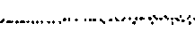

Advantages | Dis-advantages
Reduces likelihood of contaminating other subjects in the immediate area. | Requires accurate aim to hit target.
Potential for inhalation by sprayer reduced. | Only affects area struck by stream.
Less likely to be affected by wind or to be blown back in your Face | Potential for irritation of target's respiratory system reduced.
Longer range. | Takes longer to create irritation than a mist spray.
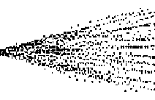
  - Full Cone Mist Spray

Advantages | Dis-advantages
Requires less accuracy | Potential for increased exposure to surrounding area, to innocent bystanders and to the sprayer
Covers a wider area, so more likely to hit target | Strong winds can diminish effectiveness
Potential for inhalation increased, enhancing effectiveness on target | Potential for inhalation increased, enhancing effectiveness on innocent bystanders and sprayer


  - Magnum Fogger

Advantages | Dis-advantages
Distributes large amounts of spray into vast area, helpful for riot conditions, crowd control, raids, and correctional use | Potential for increased exposure to surrounding area, to innocent bystanders and to the sprayer

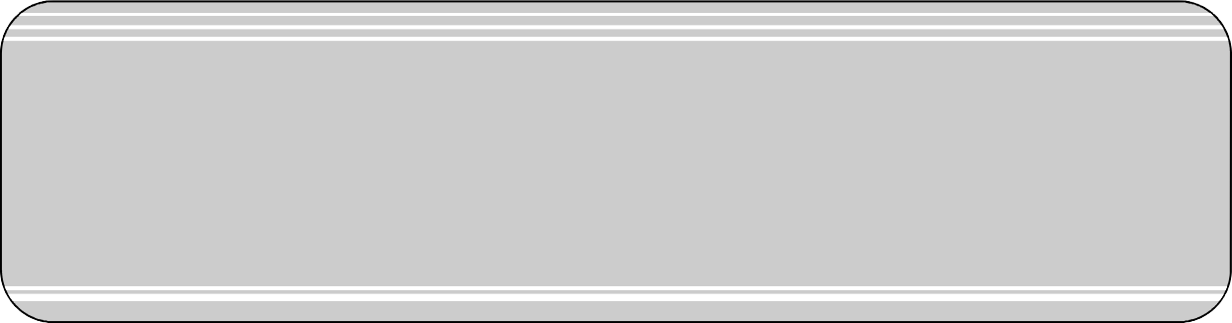

STUDY UNIT 4

TWO WAY RADIO COMMUNICATION

LEARNING OUTCOMES

On completion of this study unit the student will….

- Identify the components of a two way radio.
- Explain the operating procedures for a two way radio.
- Explain the principles of voice procedure.
- Use the phonetic alphabet during a radio transmission.
- Use common radio terminology during a radio transmission.
- Demonstrate the correct radio procedures during single and multiple radio calls.
- Demonstrate the correct radio procedures during a all station call.
- Demonstrate the correct radio procedures for emergency radio calls.
- Demonstrate the correct radio procedures when relaying messages.
- Explain the principles of radio procedures.

- Introduction
Communications among responders vary with the severity of the incident at hand. They range from simple and straightforward to intense and complex. Flexible standards have been established to guide radio communications accordingly. At one extreme (e.g., in an exchange between regular colleagues about a minor incident) the protocol may be nearly (but not quite) as informal as in ordinary conversation. At the other extreme (e.g., among teams from several patrol routes responding to a major incident) the protocol may be nearly (but not quite) as formal as in a planned operation.

- Definition

Radios may operate at any frequency where they are licensed to do so, though typically they are used in the various bands between 60 and 900 MHz. They may use simple modulation schemes such as AM or FM, or more complex techniques such as digital coding, spread spectrum, and so on. Licensing terms for a given band will usually specify the type of modulation to be used.

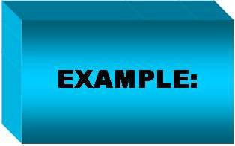
For example, airband radiotelephones used for air to ground communication between pilots and controllers operates in the VHF band from 118.0 to 136.975 MHz, using amplitude modulation.

- Components of a two way radio

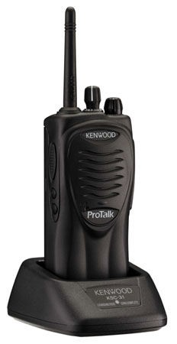
Antenna

Volume Frequency/channel

Press to talk/PTT

Charger

- Radio procedures

  - Do’s & Don’ts

- Don’t use abusive language over the radio.
- Don’t play music in the background.
- Keep the radio/control room secured.
- Treat radios as technical equipment and handle them with care to prevent damage.
- Use the radio for the transmission of official messages only.
  - Operating rules

Only one station can speak at a time. To prevent confusion the following rules must be adhered for:

- Listen out before speaking to ensure that the frequency is clear and do not cut in on other transmissions. Allowance must be made for transmission where you can hear only one of the participants in a conversation.

- Observe short pauses between phrases and at the end of a conversation to allow for break-in-working. The press-to-talk (PTT) switch or the voice-operated switch (VOX) must be released when pausing.

- Answer all calls immediately and in the correct sequence.

- Ensure that the radio set returns to receive after each transmission. A jammed PTT switch will reduce a good net to a state of chaos.

- To utilise circuit time more efficiently, all messages or their substance must be written down prior to transmission. Those messages which must be delivered by the receiving operator to another person or which are preceded by the pro-word “MESSAGE” must be written down.

- Transmission via radio should be clear with a natural emphasis on each word and should be spoken in natural phrases, not word by word.

- if this procedure is followed, no complaints can result

- When it is necessary for a station to initiate test signals, either for the adjustment of a transmitter, before making a call, or for the adjustment of a receiver, such signals will not continue for longer that 10 seconds, and will consist of spoken numerals (1,2,3, etc) followed by the call sign of the transmitting station.

- The station that begins the transmission must also terminate it.

- Principles of voice procedure

The principles of good voice procedure are well defined by the use of the key words
“BASS”, “RSVP” and these must be memorised by every radio user. Details are:

  - BASS

Brief: message must be brief and only contain important facts.

Accurate: details given must be clear and accurate.

Security: never transmit classified information unless it is disguised in some way.

Speed: do not rush the message but be brief and concise.

  - RSVP

Rhythm: use short phrases with pauses.

Speed: remember the receiver may wish to write down the message.

Volume: do not shout but speak slightly louder than normal.

Pitch: pitch the voice slightly higher than normal.

- The phonetic alphabet
A message transmitted over a radio can sometimes be very indistinct and difficult to understand.

During world war 1 a system of accurately transmitting a radio message was devised whereby each letter of the alphabet was given a word, so that any message could be spelt out and by so doing remove any chance of misunderstanding.

This system of words became the phonetic alphabet and was standardized internationally. The phonetic alphabet is still used today whenever radio communication takes place, from the Police and Defense Force to International Air Traffic Control and amateur radio communicators.

This ensures that any message which although it might contain call signs, codes, difficult words or names will be understood by the receiver of that message.

A | ALPHA | J | JULIET | S | SIERRA
B | BRAVO | K | KILO | T | TANGO
C | CHARLIE | L | LIMA | U | UNIFORM
D | DELTA | M | MIKE | V | VICTOR
E | ECHO | N | NOVEMBER | W | WHISKEY
F | FOXTROT | O | OSCAR | X | X-RAY
G | GOLF | P | PAPPA | Y | YANKEE
H | HOTEL | Q | QUEBEC | Z | ZULU
I | INDIA | R | ROMEO

All radio users must know this phonetic alphabet.

- Common words and phrases
As with the phonetic alphabet, the following phrases are globally accepted as
‘radio-speak’. Using these phrases ensures that all radio operators – even from other countries and our emergency services – will understand each other.
CALL SIGN: Call sign of station as registered and reflected on the radio licence.

ABBREVIATED CALL: Unofficial domestic call, signs arranged by individual companies.

OVER: My message is complete and I am expecting a reply.

OUT: My message is complete - do not reply.

ROGER: I have received your message. I understand your message. Everything is according to plan.
SITREP: Situation Report

MAYDAY: Emergency Call (repeat at least twice)
SAY AGAIN: Repeat your message
I SAY AGAIN: I am repeating my previous message or portion thereof.
RELAY TO ....(Call Sign): Pass my message on to ....... (Call Sign)

- Radio controls

Before commencing a transmission, the user must ensure that the net is clear. The operator uses his own call sign to identify himself first and thereafter the call sign of the station or stations he is calling. Once the link is established an abbreviated call sign (ACS) may be used.

  - Single Call

This is a single transmission between two stations.

The communication process consists of four definite phases.:

- Waiting for a break in air traffic
- Establishing contact
- Sending the message
- Ending contact

Waiting for a Break in Air Traffic:

- Never interrupt other traffic unless it is an emergency

Establishing Contact:

- Establish contact be first identifying yourself

- Assume you are Foxtrot and you want to communicate to whiskey. You will initiate contact by transmitting:

- Whiskey this is Foxtrot - message - over≅

- Whiskey will respond:

- Whiskey - send message - over≅

Sending the Message

As contact has now been established communication can now take place. Before communicating the person whom intents to communicate must first identify himself by using his own call sign before mentioning the other party’s call sign.

Bear in mind that every time a statement has been completed and a response is expected, such a transmission must be completed with the word “over”

Ending Contact

Should the exchange of information be completed, either party may end the transmission with the pro-word “out”.

Other stations on the net will now know that the channel is open for new communication.

  - Multiple Call
- Sender's call sign: Z R 123
- Receiver's call sign: A 1

- The phonetic alphabet is used to spell out the call sign,
i.e. Zulu Romeo 123, or Alpha 1and the message transmission would be ……….
- If the control call signs isZR123, control would say:
- Alpha 1, Alpha 1; Alpha 1; this is Zulu Romeo 123
………..Over
- And ZR123 would respond:
- Zulu Romeo 123, Alpha 1 standing by, send
………..Over

Senders of messages are the only persons that can end a message i.e. "Zulu Romeo 123 Out". All other persons responding to the originator must reply "Roger over". Note that when ending a message, the operator will use the word "over" or "out", depending upon whether a reply is required or not. The phrase "over" and "out" is never used.

This occurs when the control station calls a number of outstations on the net. The opera- tor at control uses his own call sign to identify himself, and thereafter the call signs of the stations he is calling.
  - ALPHA 1, DELTA 2 and PAPPA 6 this is BASE message over.

Station will answer in the same sequence as called

  - BASE this is ALPHA 1send over.
  - DELTA 2 send over.
  - PAPPA 6 send over.

BASE will now send the message and all of the stations will reply in alphabetical order.

As soon as BASE has been satisfied he will end the trans- mission.

  - All Stations Call

This is when the Control Station is calling all the stations on the net.

    - All stations this is BASE message over.
    - ALPHA 1 send over, BRAVO 3 send over, CHARLIE 4 send over.
    - BASE confirm postings for today over.
    - ALPHA 1 (message) over, BRAVO 3 (message) over, CHARLIE 4 (message) over.
    - BASE out.

Stations will respond in order of numerical sequence of call signs. It should be noted that an

  - Emergency Calls

“All Stations” call would normally only be used on a small net.

Emergency calls are designed to arouse the attention of all stations. Emergency procedures must be pre-planned.
    - BASE this is ALPHA 1 MAYDAY MAYDAY over.
    - ALPHA 1 this is BASE send (your emergency) over.

  - Relay Messages

It sometimes happens, mainly as a result of distance, that two stations cannot speak to one another. If, however, there is a station between any two such stations, which has communication with both, such station can be used as a relay.

Procedure

- CONTROL wants to send a message to TANGO 2, and he uses TANGO 3 as a relay station. CONTROL must confirm that TANGO 3 has communication with TANGO 2.
- If so, CONTROL sends the message to TANGO 3, for relay to TANGO 2.
- TANGO 3 relays the message to TANGO 2, and gets an answer back from TANGO 2.
- TANGO 3 relays TANGO 2's answer to CONTROL.

TANGO 3 this is CONTROL, do you have communica- tion with TANGO 2, over
TANGO 3 positive, over
CONTROL, relay message to TANGO 2, over
TANGO 3, send, over
CONTROL, they must come over to my location, over
TANGO 3, roger, out

  - TANGO 2, this is TANGO 3, message from CONTROL, over
  - TANGO 2, send, over
  - TANGO 3, CONTROL wants you to move over to his location
  - TANGO 2, roger, over
  - TANGO 3, out

  - CONTROL this is TANGO 3, message, over
  - CONTROL send, over
  - TANGO 3, message sent, over
  - CONTROL roger, over
  - TANGO 3, out

- Principles of radio procedures

- Do not use abusive language over the air. Apart from prejudicing voice procedure, this can result, in licenses being revoked.
- Do not play music in the background.
- Do keep the radio room secure.
- Do treat radios as technical equipment and handle them with care to prevent damage.
- Do use radios for the transmission of official messages only; the transmission of music or other entertainment is prohibited.
- Always use the correct call sign.
- Ensure that the battery is always fully charged.
- Always carry out a radio test before going on duty.
- Keep messages short, concise and to the point.
- Prepare all messages mentally before transmitting them.

- Use codes as far as possible.
- Excessive testing of the radio is forbidden.
- Remember to release the transmit button after each message.
- Never switch the radio off


STUDY UNIT 5
METAL DETECTORS
LEARNING OUTCOMES

On completion of this study unit the student will….
- Discuss the purpose of hand-held metal detectors.
- Demonstrate the correct use of a handheld metal detector.
- Demonstrate skills in the use of a metal detector when a search from the front and back needs to be conducted.
- Discuss the legal guidelines that apply when using hand held metal detectors.
- Explain the function of a walk through metal detector.
- Describe the safety aspects for the use of hand held metal detectors.

- Introduction
Mention the words metal detector and you'll get completely different reactions from different people. For instance, some people think of combing a beach in search of coins or buried treasure. Other people think of airport security, or the handheld scanners at a concert or sporting event.

The fact is that all of these scenarios are valid. Metal-detector technology is a huge part of our lives, with a range of uses that spans from leisure to work to safety. The metal detectors in airports, office buildings, schools, government agencies and prisons help ensure that no one is bringing a weapon onto the premises. Consumer-oriented metal
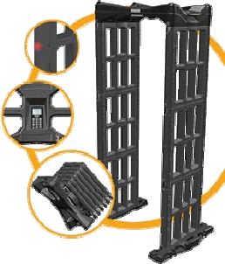
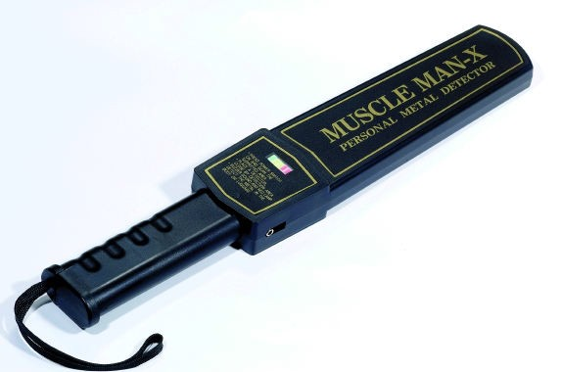
detectors provide millions of people around the world with an opportunity to discover hidden treasures (along with lots of junk).

In this study unit , you'll learn about metal detectors and the various technologies they use. Our focus will be on consumer metal detectors, but most of the information also applies to mounted detection systems, like the ones used in airports, as well as hand- held security scanners.

- Definition
  - Handheld metal detector

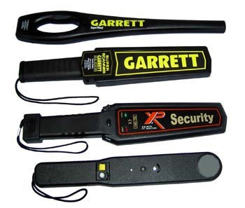
The hand-held metal detector is a battery operated, lightweight device used to sense the presence of objects made of any type of metal. This device is light and portable and can be used with ease at any location on a site.

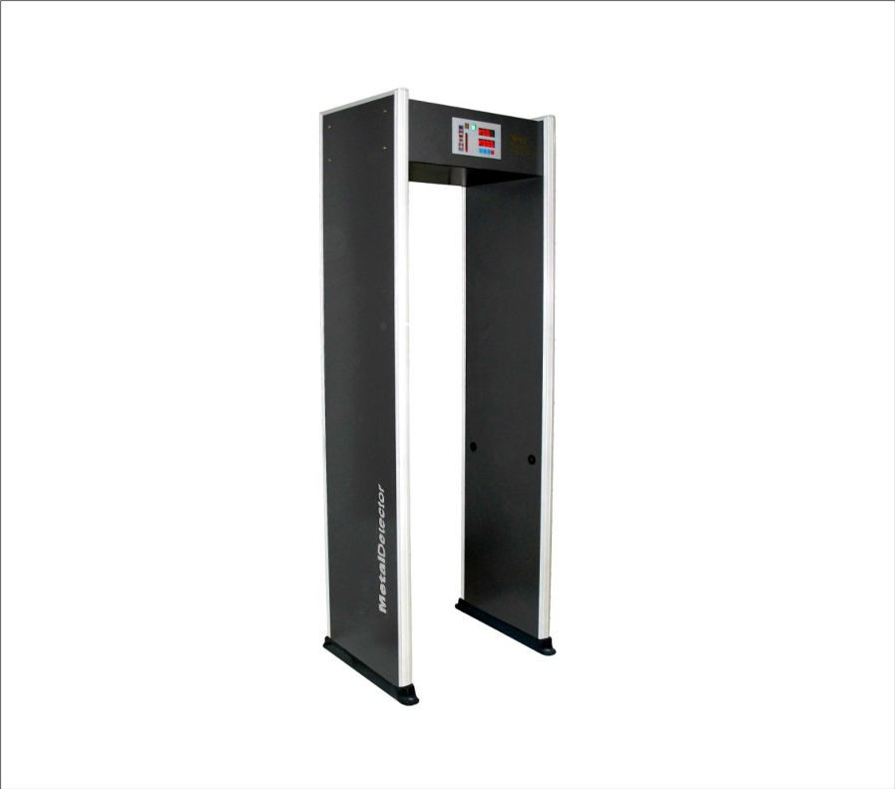
  - Walk through metal detector

The walk through metal detector is an electronic operated device which typically are used in a variety of environmental conditions and can be used both indoors and outdoors to sense the presence of objects made of any type of metal.

- Searching with a hand held metal detector.
The security officer must do a hand held metal detector search according to the following steps and know how to use a HHMD:

- Make sure that the hand held metal detector is in working order.

- Searches must be done by moving the hand held metal detector + 20mm (2cm) from the body or item.

- Security equipment Page 34 of 55 Use and maintain basic security equipment - 12328 NQF 03 General Security Practices

- The person must face the security officer when the search is being done.

- Start with the headgear and hair by moving the detector from the left side over the crown of the head to the right side of the head.

- Move the detector from the collar and shoulders down the front of the person to the waist on the left side then from the shoulder to the waist down the right side. Repeat at the back.

- Operating a handheld metal detector

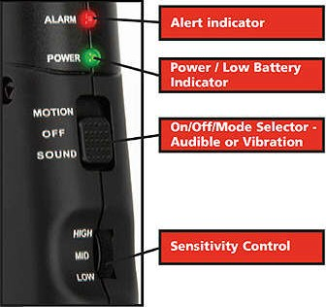
Turn on the power switch, if a click sound
is heard, it indicates that the power has been connected, and the green LED will turn on at the same time.
If no click sound is heard, it indicates that no battery has
been installed or the battery is not well connected. If the click sound is heard one after another, it indicates that the battery can NOT be used any more and a new battery shall be installed.

- When the switch click sound stops, the highly sensitive detection can be performed. Grasp the handle and detect with the detection face around the object being de- tected, there will be an alarm when a metal object is detected.

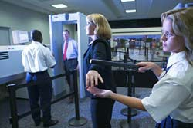

In the mean time, the green LED will turn into red. When the When the detection stops, the alarm stops and the red LED turns into green,
  - Sensitivity adjustment

- The sensitivity shall be adjusted when performance instability is observed or sound is produced when detecting human body without any metal stuff because requirement or the sensitivity is too high.

- Insert a small straight –shaped screw driver into the small hole of the handle of the detector and rotate clockwise until a sound is heard, then rotate counter- clockwise barely to the position where no sound is produced, then rotate for another half a circle, until the sensitivity meets the requirement.

- Practical use of the scanner
  - The Scan from behind

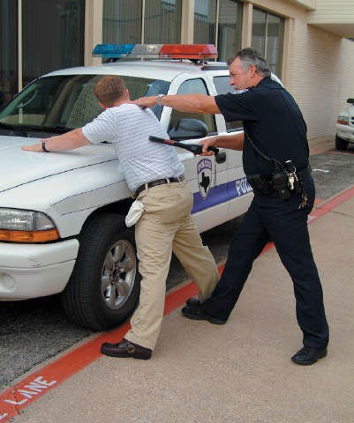
    - Stand behind person to be searched, instruct person to assume a position with arms outstretched to their sides, palms out parallel with the floor/ground, legs spread out with feet shoulder width apart.

    - Place side of wand, regardless of left or right, at the top of their head, maintaining a distance of 1”-2” from the body, and scan over each side of their head, then sweep from neck down the center of the back to the waist and buttocks, scanning to the sides of their waist and back up to the shoulder –both sides - work your way from top of one shoulder outwards to the extended hand. Go out past the fingertips and return under the hand, scanning the underside of the arm (pay attention to alerts on watches/jewelry on wrists). Sweep inwards to the armpit, and continue downwards to the foot. At the foot ensure that you scan across the outmost upper side of the shoe.

For boots and hiking shoes the scanner will alarm on detecting eyelets and speed lace rings. It is best to have them remove those shoes for inspection, depending on the security threat you are facing).

  - Continue the scan around the heel and scan the inside top of the foot, - have them lift their foot up to scan the bottom of their foot, then sweep upwards between the legs to the crotch (Note: for dresses stop at hem or just above the knee and go down the other leg.

  - You will to need to conduct a slower scan around the buttocks and thigh/abdomen area from front and rear). Again, maintain 1”-2” distance and go downwards inside the opposite thigh to the floor, repeating the scan for foot as before, except this time go from inside foot/ankle area to outside of the ankle and foot (scan bottom of that foot too). Proceed back up the other side of the person to armpit, out to the hand and around it, to the top of the shoulder.

  - The scan from the front
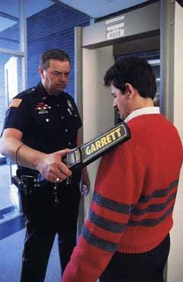
    - Now step in front of person while their arms are still outstretched, and begin the scan with the wand parallel with their shoulders and begin the scan outwards to the hand, then back to the armpit and down to the waist. Ensure that you keep the wand 1”-2” for this scan to reduce grounds for harassment complaints.

Pay attention to alarms on shirt buttons. Scan the belt front area, and then go down one side to the ankles, back up between the legs, down to the other ankle, and back up the other leg. Focus here will be caution on the sock area, and calf/thigh areas for secured weapons.

Note on Hats and Coats: best method is have them remove them and screen through x-ray if available.

  - If the coats are on then you must conduct the same screen as normal from behind, but from the front ask that the coat be opened. Holding the coat front lapel then in- sert the wand from the front inside to scan the underside of the jacket from armpit to waist. Do the same for the other side. – For Hats, scan the perimeter of the hat and the bill of the hat.
•
  - Speed of Movement of the Seeker – per National Institute of Justice standards you Should move the detector at a speed of about 0.5 meter per second for Small Objects: handcuff key, small caliber cartridge, small non-ferrous/non-magnetic stainless steel knife. Speed for Very Small Objects will be 0.5/meter/second: disposable razor blade, hypodermic, metal ink pen refill. Speed for detection of a pistol; 2 meter/sec, and 4” knife will be at 1meter/second.

To assist in this we recommend that you take a yardstick / meter stick and lay it on a table top. Practice scanning from one end to the other as you say in your head: “one
and two”. This will give you a half second count for establish- ing .5/meter/second. You should be at the middle of the yardstick on the word “and”, and at end of the yardstick after saying “two”. (A count of “one thousand one” is for 1 meter/ second.)

Use these counts mentally as you use the scanner on a test subject to establish the speed at which you will conduct your scans. Use it mentally as well to prevent too fast of movement during real scans.

Remember: the object is to conduct the scan without contacting the person. Certain facilities will have some leeway with this, particularly correctional facilities.

- Legal guidelines when using a hand metal detector.
As a security officer you do not have the right to search any person without his or her consent. Using the HHMD is also regarded as a search and you will need the person’s permission to search them.

Should the HHMD show that there is a metal object on the person, you may not remove it yourself. Ask the person to explain the object and to remove it if you believe it is necessary.

- Safety guidelines.
  - When using HHMD’s the security officer should always bear the following in mind:

  - Position yourself in such a way that you will be able to defend yourself should the person being searched decide to attack you.

  - Do not use HHMD’s to search people with pacemakers (heart beat assistance items) as the HHMD might interfere with its operation.

  - Do not attempt to open or maintain the HHMD yourself, as there are many safety risks involved in doing so. Only authorized trained technicians may perform maintenance tasks.

- Function and characteristics of Walk through metal detector.

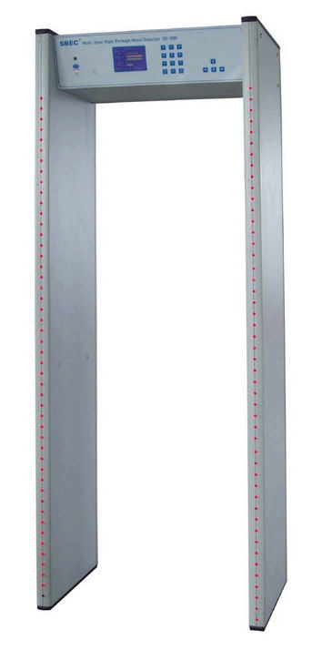
- Six detecting areas: allocation of six mutual
over-lapping detecting areas, adopt the advanced digital pulse technology, both side of the gate can transmit and receiving the signal, can eliminate the false alarm areas and accurately determine the location of the metal objects.

- Indication of the alarming areas: the monitor can accurately indicate the prohibited articles which are hidden at the places of human body with corresponding height. The alarming areas can be indicated by the column lamps at the right side of operation panel.

- Adjustable area sensibility: with the highest sensibility, it can detect the metal article as small as one coin. With the range of 0-99, it can automatically adjust the sensibility, according the weight, volume, and location of the metal parts and eliminate the false alarming for the coin, key, jewelry, leather belt buckle, etc.

  - High capability of anti-interference: the adoption of digital, analogy and left and right balanced technology can prevent false or omitted alarming, which greatly enhance the capability of anti-interference.

  - Protection with password: the protection from the password can only allow the authorized person for the operations. It is highly safe.

  - Functions of statistic counting: the intelligent counter can calculate the number of the passenger flow and the times of alarming.

  - Harmless to human body: adopt the technology of low electromagnetic to transmit, the product is harmless to heartbeat of human body,
  - pregnant women, magnetic software, tapes and video recording tapes.

  - Power safety: the power device for the product is installed at the top of the main unit. The power supply can be controlled by the operation panel.

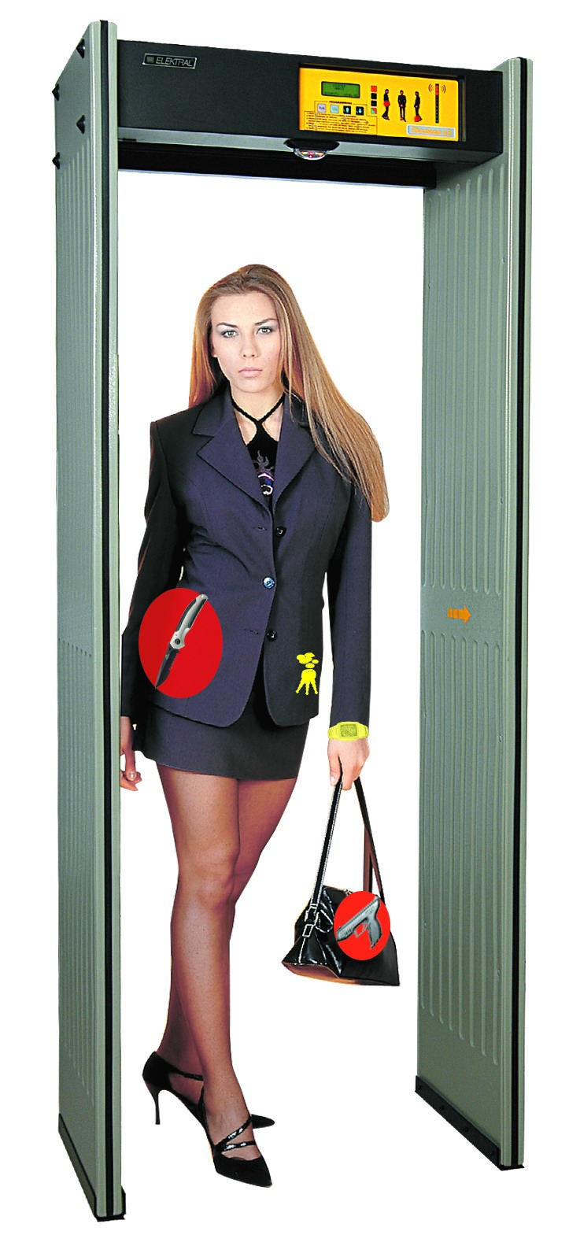
•
Convenience in installation: Series prod-
ucts adopt integration design. It only takes twenty minutes to install the gate. The user's manual are attached with the prod- uct.
•
Application scope: it can be used in the
factory, prison, court, exhibition hall, stadium, entertainment lieu, etc., where the prohibited articles need to be checked for safety.


STUDY UNIT 6
BODY ARMOUR
LEARNING OUTCOMES

On completion of this study unit the student will….
- Explain what body armor is.
- Discuss the different types of body armor.
- Describe the purpose of body armor.
- Explain the benefit of wearing/using body armor.
- Discuss the legal guidelines that apply when using body armor.
- Describe the safety aspects for the use of body armor.

- What is body armor

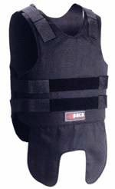
Body armor is a protective piece designed to stop projectiles. Modern body armors are also known as bullet- proof vests.

They are used by police, the Army and private security as default vest. The name bulletproof is deceptive though, as no body armor currently available can stop all bullets.

- Different types of body armor

Two big groups of body armors can be established:

  - the set used by law enforcement officers
  - and the sets used by the Army

Among the first group, there are different types of body armor characterized by increasing protection power. The classification is not easy, due to the large number of available ammunition calibers and the variations among similar caliber cartridges.

- Standards of body armor

Type I
Type IIA Type II

Type IIIA

Type III Type IV Special type
Minimum level of protection.
Protects from lower velocity 9 mm and 40 S&W ammunition.
Protects against high velocity 357 Magnum and higher velocity 9 mm ammunition.
Protects from high velocity 9 mm and 44 Magnum ammunition. Not recommended in hot or humid climate.
Protects against 7.62 mm Full Metal Jacketed (FMJ) bullets. Protects against .30 caliber armor piercing (AP) bullets.
No standard custom made, it is be based in any of the standards with addition for special
requirements.

  - Body armor standards chart
Types of ballistic resistance for body armor.

Type | Bullet caliber and type | Bullet mass (grains) |  | Impact velocity
I | - .22 long rifle high velocity | • | 40 | • | 1.050
I | - .38 round nose lead | • | 158 | • | 850
IIA | - .357 jacketed soft point | • | 158 | • | 1.250
IIA | - 9mm full metal jacket | • | 124 | • | 1.090
II | - 357 jacketed soft point | • | 158 | • | 1.395
II | - 9mm full metal jacket | • | 124 | • | 1.175
IIIA | - .44 magnum lead semi wadcutter gas checked  - 9mm full metal jacket | •  • | 240  124 | •  • | 1.400  1.400
III | - 7.62 mm full metal jacket | • | 150 | • | 2.750
IV | - .30-06 armor piercing | • | 166 | • | 2.850

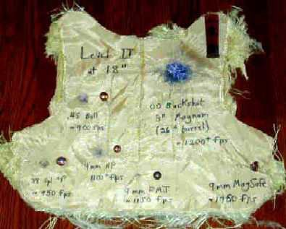
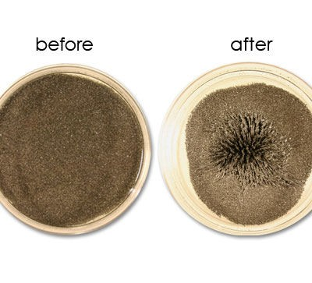
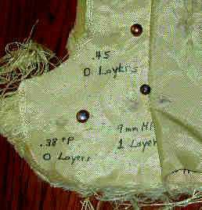

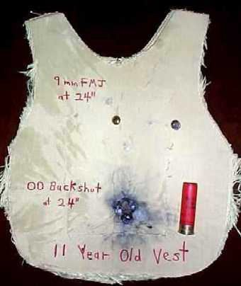

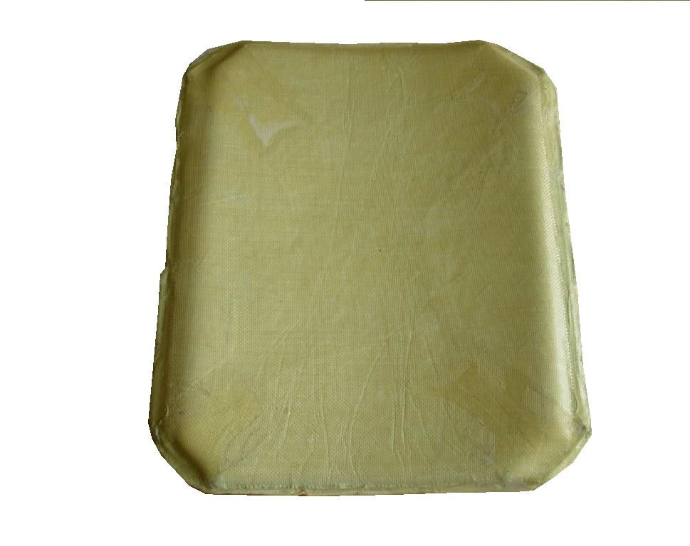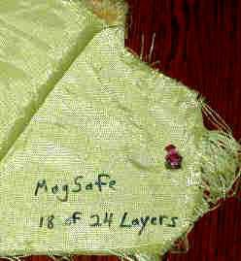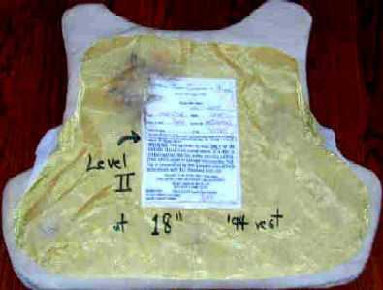
BODY ARMOR
PLATE
LIQUID BODY ARMOR

- The purpose of having body armor

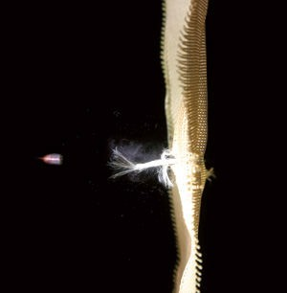
- Benefits of wearing Body Armor

First, armor stops weapons or projectiles from reaching a person's body. Second, it diffuses the weapon's energy so that the final impact causes less damage. While it's not effective in every situation, armor can generally help protect people from serious injury or death, especially against the right weaponry.

  - Body armor saves lives. According to industry estimates, more than 1,200 officers have been saved from death or serious injury because they were wearing their armor. This figure includes lives saved and serious injury avoided from assaults and accidents as well as from ballistic threats.

  - Body armor offers flexibility to the wearer in a number of ways:

⇒ It is available in various levels of protection to accommodate the range of ballistic threats facing wearers (including street assaults and the officers’ own weapons and ammunition).

⇒ It can be worn as a concealable undergarment; incorporated into a uniform shirt, vest, coat, or other type of outer garment; or worn over the uniform and easily recognizable (such as armor worn by special tactical teams).

⇒ Many models are available in a variety of coverage's, some armor panels cover the front and back of the torso, while others also wrap around the sides.

⇒ Ballistic panels can be removed from the carrier on some models so the carrier can be thrown into the washing machine. Many different types of carrier materials are available.

  - Angle of Incidence

The angle between the line of flight of the bullet and the perpendicular to the front surface of the backing material fixture as shown in the image below

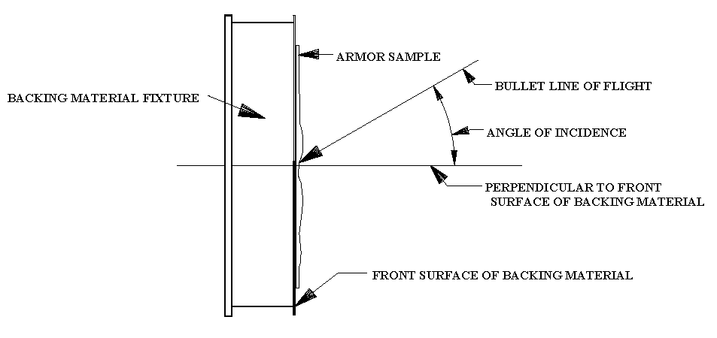

No Armor Protects From All Ballistic Threats

Although some restrictions apply, the advantages of wearing body armor far outweigh any limitations.

Note the following restrictions:

    - Soft body armor is not designed to protect against rifle bullets or edged or pointed weapons.

    - Hard or tactical armor, designed to defeat rifle bullets, incorporates metal or ceramic plates and is generally too heavy, bulky, and conspicuous for routine wear.

    - Armor that incorporates ballistic plates designed to de- feat rifle bullets offers protection only from rifle bullets that impact the limited areas covered by the plates. However, the soft armor supporting the plates will pro- vide ballistic protection against handgun ammunition that the soft armor is labeled to defeat.

    - Armor designed to defeat armor-piercing bullets may provide protection only against a single-bullet impact on the ballistic plate. Again, the soft armor supporting the plates will provide ballistic protection against handgun ammunition that the soft armor is labeled to defeat.

- Armor cannot be expected to provide adequate protection from ballistic threats that strike too close to the edge of an armor, or too close to another impact. Although manufacturers have recently come out with new fabrics that claim to be more comfortable, there generally is a tradeoff between comfort and protection. The higher the level of protection worn, the more layers of ballistic material and stitching are required, adding to an armor’s weight and bulk. Although discomfort may result from an armor’s weight, bulk, or stiffness, such discomfort may be due to a bad fit or the strapping on of armor too tightly. If possible, conduct a wear test before purchasing armor.

- Safety Instructions

No body armor is bulletproof. Manufacturers rate armor in accordance with the standard threat levels. Although body armor will generally protect against bullets identified by manufacturers’ at those specific threat levels, the armor could be penetrated if impacted by a bullet of a higher threat level.

Remember, bullets may also penetrate armor when the impact is too close to the edge of the armor or too close to another impact. Follow these guidelines for safe use of your armor:

- Be sure to read the label on your armor. Familiarize yourself with its level of protection. Labels on armor must identify designated levels of protection and warn if the armor does not protect against rifle fire or sharp-edged or pointed instruments.

- Manufacturers may also add additional safety instructions or information to labels.

- Read and retain for future reference any safety literature accompanying your armor.

- Follow care and maintenance instructions to ensure your armor’s intended performance (see “Care and Maintenance”).

- Seek medical attention if you are shot while wearing your armor, even if the bullet does not penetrate. Although armor protects against blunt trauma from non- penetrating bullets, internal injuries requiring medical attention may still result.

- Replace your armor immediately if it has been impacted by a bullet or damaged in any way. Some manufacturers replace armor free of charge if they are provided with official documentation concerning the incident.

- Make sure your vest’s level of protection corresponds to the types of threats you face on the streets and that your vest protects against your service weapon and ammunition.

- Remember that proper fit aids in your armor’s effectiveness and comfort.

- Conduct visual inspections of your armor.

- Become educated about proper cleaning methods (see “Care and Maintenance”).

- Follow the inspection/replacement procedures recommended by the manufacturer
- and your department.

- Keep manufacturer addresses and telephone numbers handy. Many manufacturers
- provide a toll-free 800 number for their customers.

Wear your armor.
- Legal guidelines

The only applicable legal guidelines for the use of body armor are found within the Occupational Health and Safety Act, referring to the use and issue of personal protective equipment and the employee’s duty to use issued equipment to ensure his safety.

STUDY UNIT 7
FLASHLIGHTS
LEARNING OUTCOMES

On completion of this study unit the student will….
- Demonstrate skills and knowledge for the correct use of a flashlight.
- Demonstrate knowledge and skills in changing the battery of the flashlight during take over of shifts.
- Demonstrate the correct carry method of a flashlight during a security patrol.
- Demonstrate knowledge by explaining the difference between a battery operated flashlight and a re-chargeable flashlight.
- Describe the safety aspects applicable to flashlights.

- Introduction

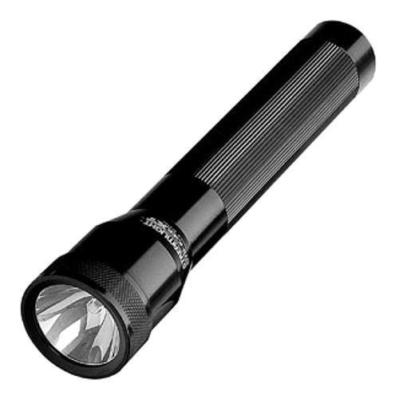
All security officers should have a working flashlight, even when working during daylight. They may have to enter a darkened building or room. Any flashlight is better than no flashlight, but the most common is the “maglight” style. The three
-battery maglight is more than enough illumination for anything short of search and rescue work.

Security officers should employ the same mentality for law enforcement gear as with their field gear, “If you can’t afford to loose it, don’t take it.” Many maglights are rechargeable and this is a great way to insure the light doesn’t go out at an inopportune moment.

The maglight is not to be used as an impact weapon unless as a last resort in a deadly force situation.

Even though not used as an impact weapon, the flashlight can still be used in self- defense. It’s presence in the hands of an officer intimidating and practical. At night, a suspect’s eyes are adapted to darkness in some degree and shinning a maglight into the eyes will not only blind, but actually stun an offender momentarily. Placing weight in the light may cause a lawful use of force to become unlawful.

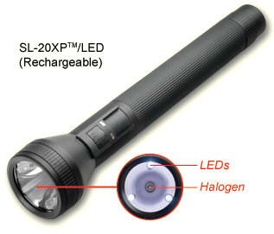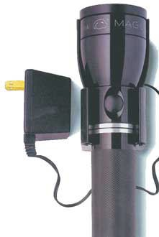

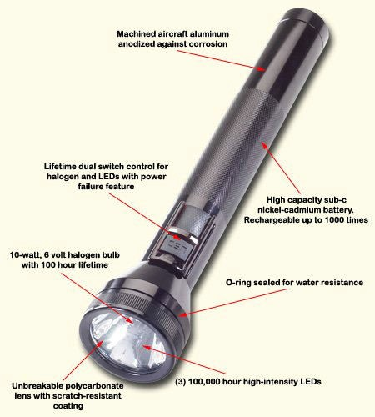

- How to use the flashlight
  - Holding the flashlight
- The officer should take the flashlight in their non-firing hand. It is grasped with the pinkie finger near the lens and the thumb near the rear of the light. The index finger will turn the light on and off.

- When shinning the light, the officer should hold it over the shoulder, up and away from the body. This is in case an offender starts shooting at the source of the light. It reduces the chances of the officer being hit.

- This method of holding the flashlight also provides the officer with a self-defense option. In a worse case scenario, the officer can swing the light down, using the butt of the light as the impact point. This is not a traditional use of force and should only be used in a life or death situation. If the officer employ the light in this manner, they try to strike at the weapon or wrist of the offender.

- Also, a strike to the collarbone will likely break it, incapacitating both arms.

- If at all possible, the officer should avoid using the maglight as an impact weapon due to possible liability and use of force issues.

When utilizing the light in this manner, it is very easy to seriously injure or kill an offender so extreme care must be taken. Once again, the flashlight should not be used to strike an offender unless the situation would call upon deadly force.
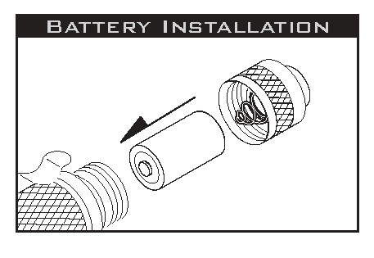
•
Unscrew the tailcap to install or replace
the batteries.

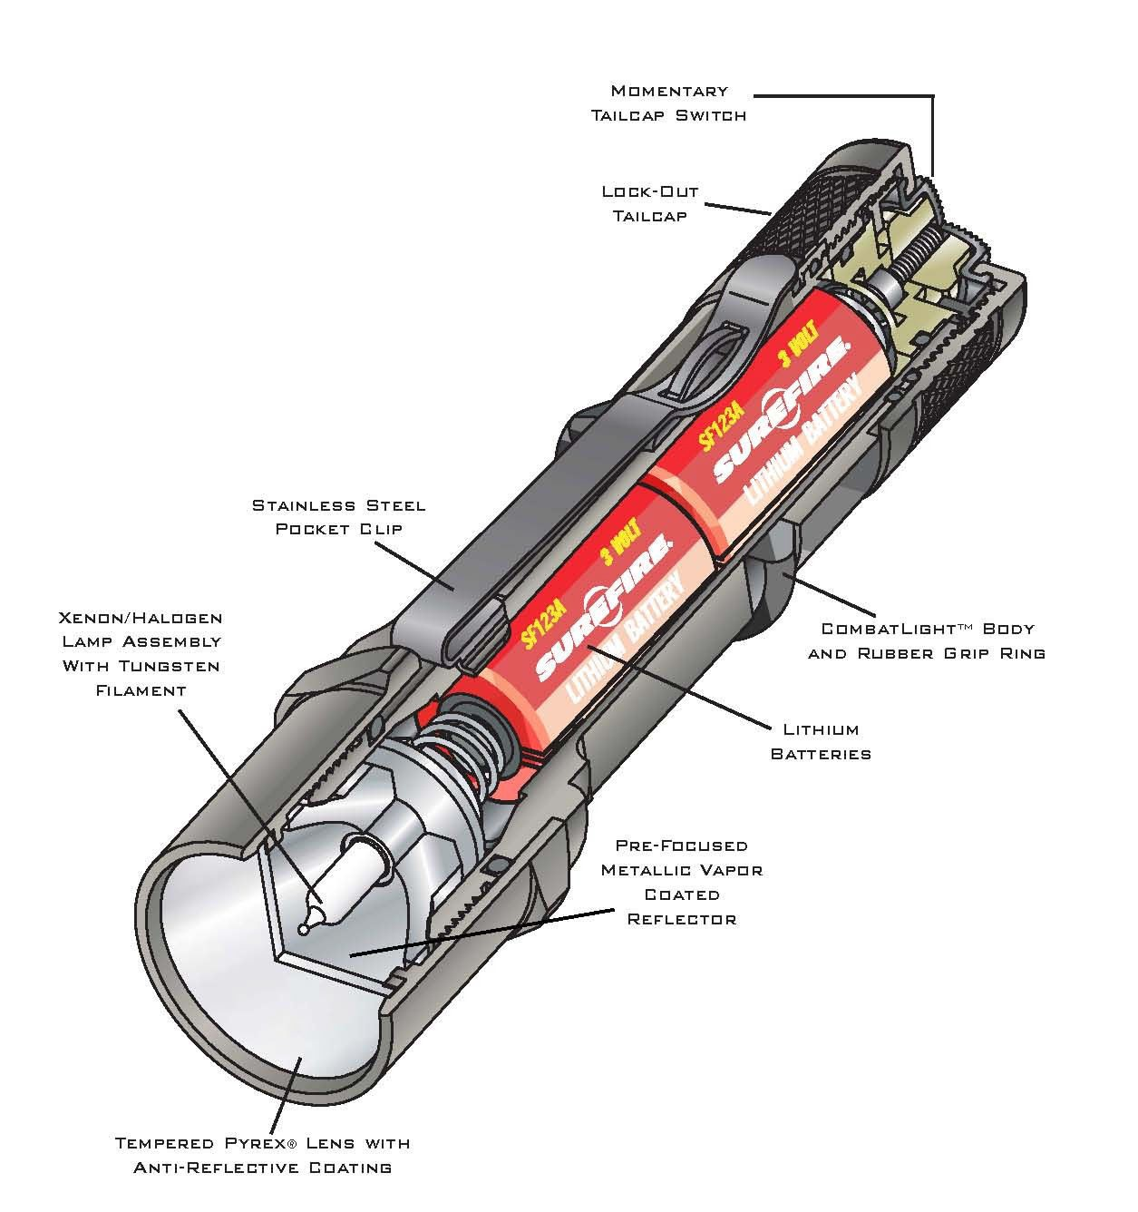

- Changing the battery of the flashlight
- Unscrew the tailcap to install or replace the batteries.

- Lock-out Tailcap

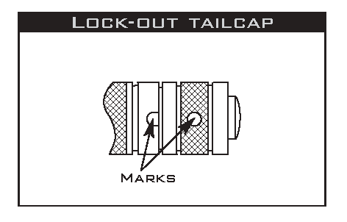
- Models with a lock-out tailcap have ma- chined marks aligned in the lock-out po- sition to prevent accidental activation.
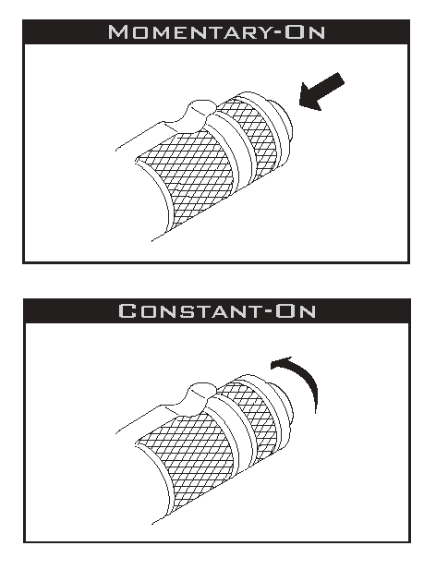
- To unlock and place in momentary-on position, rotate the tailcap clockwise approximately one turn.
- Momentary-On
- Depress the tailcap pushbutton to activate the light in momentary mode.
- Constant-On

- From the momentary-on position, rotate the tailcap clockwise approximately one- half turn to achieve constant-on activation.

- Carry the flash light

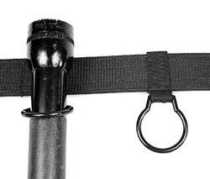
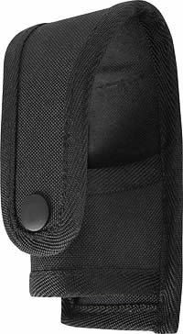
Security officers should take note that belt holders are part of the standard gear when a flash light forms part of the uniform.

The image on the left and below shows a typical belt clipper/flashlight pouch where the flashlight can be worn during duty.

This holder will hold your flashlight firmly in place to enable you to move or run without losing your torch.

- Battery-powered vs. Re-chargeable?

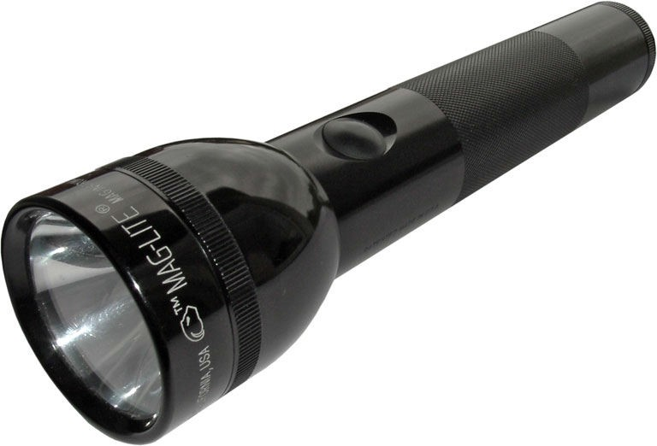
  - Battery operated flashlight

Non-rechargeable flashlights don't use ordinary AA, C, and D size alkaline batteries. They use 123A lithium batteries because of their multiple advantages over alkalines:

- longer shelf life (10 years), higher
- power density, higher unit voltage (3 volts), lighter
- weight, better cold weather performance, and better volt- age maintenance.

  - Re-chargeable flashlight

The rechargeable batteries use time-tested Nickel-Cadmium technology. Coupled with Rapid Smart Chargers you'll get reliable performance and hundreds of charging cycles from your battery.

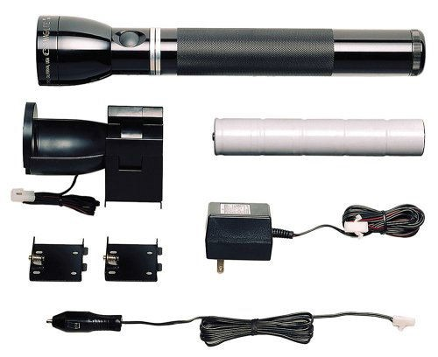

7. Safety guidelines when using a flashlight.

In order to protect themselves, workers should follow these precautions:

- Read and follow manufacturers’ recommendations for product use
- DO NOT MIX batteries of different brands
- DO NOT MIX old and new batteries
- DO NOT MIX alkaline with non-alkaline batteries
- DO NOT USE damaged batteries
- Ensure that proper polarity is observed when installing batteries
- PRIOR TO THEIR USE IN FLAMMABLE ATMOSPHERES, inspect approved battery powered flashlights to ensure that the batteries are in good condition, and that the proper
- batteries are installed correctly.
- DO NOT inspect the flashlight in a hazardous area or near an open flame.


STUDY UNIT 8

KEYS

LEARNING OUTCOMES

On completion of this study unit the student will….

- Demonstrate knowledge of key control measures by explaining it.
- Demonstrate knowledge of non-mechanical locks.
- Demonstrate knowledge of the various locking system components.
- Demonstrate knowledge by explain and applying the following procedures:

⇒ Procedures for control of locking devices
⇒ Procedure for possession of locking devices
⇒ Procedure for the control of keys

- Explain the control of combination to combination locking devices

- Key control measures

- Use Interchangeable or Removable Core Locks. These will permit frequent and rapid changes without floor or shop labor. Adequate preplanning will assure that sufficient replacement cores in the various control and master groupings are on hand for immediate use. If a locksmith is on staff, as probably there will be because of the volume of lock changes and installation, much of the core preparation can be done in-house after a suitable system start by the manufacturer.

- Do NOT Utilize Single Control or Grand Master Scheme. The obvious danger is total compromise of the locking system through loss of loss of
accountability of a control or grand master key (or code), or a single core containing the control and grand master combinations.

- Multiple Controls and Multiple Masters. The building can readily be divided into functionally different units. For example, the low-rise, mid-rise, and high-rise floors can be regarded as separate locking zone. Each zone can then be set up to its own control and its own master scheme.

- Multiple Key Blanks. In setting up different control and master schemes for major building elements, it is urged that the key blank style (the profile of the key and keyway) be different for each of them so that a blank for use in one element will not enter the keyway in the other elements. This will avoid unauthorized key use and discourage attempts at it. It would also make the lock combination codes used in one sector available for use in another with low risk of compromise inasmuch as the key blanks would not be interchangeable.

- Arrangements With Single Zones. Any of the customary approaches of distinction by floor or occupancy or both will serve. For example, if the mid-rise is a tenant section, then each of the floors could be provided a separate floor master and all floors included in a zone grand master. At the same time, spaces within the tenant zone which were not for tenant use, such as the maintenance spaces, could remain on separate master systems which were building-wide but confined to a special function such as electrical, mechanical, or janitorial.

- Strict Master Key Control. Master keys at the floor level should be issued on an accountable basis and only to senior personnel of single tenant occupants. If several tenants occupy a single floor, none should have a floor master. Floor masters issued on this basis should be changed after changes in occupancy as well as at the other indicated change intervals.

- Grand Master Keys. These should be issued on a daily basis only, and only to the fewest number of persons with demonstrated imperative need. Using multiple grand masters will reduce vulnerability to compromise but obviously not eliminate it. Issuing grand master keys on a “day basis” only, I.e., to be

returned to security custody prior to departure from the structure by the holder, will further limit exposure. Choosing very carefully those issued grand master keys (or even allowed temporary custody of them) will narrow the exposure still further. It must be remembered that an impression can be made of any key, in a variety of ways, in a matter of seconds and that key can be later reproduced. It is for this rea- son that absolute security in conventional locking systems is unachievable.

There is a myth in general circulation that maintenance managers or central crafts people, like electricians and all around mechanics, must carry grand master keys for an entire structure to be able to perform their tasks. It is sometimes argued that security guards on patrol rounds also require grand master keys for the same reason.

A moment’s analysis will show this to be a fallacy. Work schedules generally are laid out before the mechanic goes to an area. The required floor or several floor master keys could be issued based upon an approved work schedule. A zone grand master could be issued on the same basis if truly essential. It is hard to see, however, how a craftsman would require simultaneous entry capability to every door in the structure at the same time. In any event, appropriate keys to any area can be available on a 24-hour basis from the security (or maintenance) supervisor on duty and can be issued, as needed, to authorized individuals on an accountable basis.
Carriage of master and grand master keys as symbols of prestige is to be actively discouraged.

- Control Keys and Combinations. Obviously no one needs either unless a lock core is to be replaced or a new core pinned. The locksmith will have continuing access to both of these items, so the reliability of that person is of critical importance. Control keys should not be carried at any time except specifically when needed to make scheduled core changes.

- Exterior Doors. These should not be included on any other building master or control system because they are constantly exposed to lock decoding efforts by persons outside the structure. As they are mostly on grade or below grade levels, the doors involved will typically be to specialized maintenance spaces or to public access spaces under the security control of the owner or building manager. Exterior doors which are locked against ingress to the building also require intrusion alarm protection, whether or not the lock combinations are regularly changed.

- Lock Quality and Complexity of Combination Schemes. Although maximum security locks are probably not generally required for high-rise structures with a bal anced system of security controls, the locks chosen should be of very good quality. Interchangeable core locks which use a single tumbler (pin chamber) to set up control combinations should be avoided because of the ease of creating a control key given any operating key and a little ingenuity.

- Non-Mechanical Locks

If the building utilized automated entry at any locations, there will be electro mechanical locks (card readers, digital keyboards, or some combination). If a particular door is equipped only with the electro-mechanical equipment, and not with the conventional

building locksets, it will be secure against entry except via the automated entry device. On the other hand, such doors may at some time be converted to other use and be restored to the general building locking program. It is recommended that provision be included in the door for a general building lockset but that an operating core be installed only when needed. This will preserve the ability to modify that door with no skilled floor labor by merely deleting it from the automated system and installing an operating core.

- Special Security Control

There will be times at which absolute lock-out of an area may be required temporarily. This can often happen during a security investigation or to secure highly valuable target items on a short term basis. To accommodate this need,

It is recommended that a reserved lock scheme be maintained with limited combinations, and there will be no issuance of keys outside the security organization.

As needed, the conventional core (or blank core if the door is included in a remote or automated system) can be replaced with a security core which will have a completely different key blank than any others, and will not be on any other control or master system. In any emergency, a patrol guard with control keys, and the special security core could make the change in less than a minute.

- Locking defined

The Company locking system shall include all locking devices, including combination locking devices, used by the Company for the protection of facilities, property, and classified information.

